**Mobile Non-Contact Vital Sign Monitoring**

ECE4012 Senior Design Project

Section L2A, Wildcats

Project Advisor, Dr. Ying Zhang

Nydrel Jack, njack7@gatech.edu

Arianne Perez, aperez71@gatech.edu

Chelsi Taylor, ctaylor63@gatech.edu

Ethan Vargas, evargas30@gatech.edu

Nathanael Williams, nwilliams68@gatech.edu

Submitted

May 2, 2019

**Executive Summary**

Early detection of life-threatening conditions can be critical in saving a person’s life and can be made possible through continuous health monitoring. People living with chronic conditions or disabilities could benefit from continuously monitoring their vital signs, but this would require the assistance of a relative or an assigned caregiver. A user-friendly system that accurately measures vital signs without physical contact and without active effort from the user will provide autonomy, freedom, and a greater chance of detection of life-threatening conditions for those who require constant monitoring. To conveniently and effectively provide results, the system must wirelessly communicate health information in real-time to a partner application on a mobile device.

The Wildcats Team designed the MNCVSM (Mobile Non-Contact Vital Sign Monitoring) system to interface with a non-contact Doppler radar system, implement algorithms to interpret vital sign data on-board a connected microcontroller unit (MCU), wirelessly communicate the data via Bluetooth, and display the processed vital signs on a mobile application in real-time [1]. This mobile application will enable those who need regular monitoring to more easily record their vital signs and will put less pressure on family members and caregivers to provide constant supervision. Additionally, this system can be used by medical professionals to acquire vital sign readings from people with conditions that make recording vital signs difficult, such as burn victims and NICU patients.

The outcome of this design was an Android mobile application that wirelessly received heart and respiration rate data via Bluetooth from an MCU that interfaced with a non-contact vital sign monitoring system. The Wildcats Team requested $425.20 for developing a prototype and recommends selling the MNCVSM system to the public for $300.

**Table of Contents**

**Executive Summary** ii

1. **Introduction** 1
   1. Objective 1
   2. Motivation 2
   3. Background 3
      1. The NAHOM System 3
      2. Camera-Based Non-Contact Vital Sign Monitoring 3
      3. Under-the-Bed Non-Contact Sensors 4
      4. Doppler Radar Non-Contact Vital Sign Monitoring 4
2. **Project Description and Goals** 5
3. **Technical Specifications & Verification** 6
4. **Design Approach and Details** 7
   1. Design Approach 7
      1. Microcontroller with On-board Sigma-Delta ADC 8
      2. Signal Processing for Extracting Respiration Rate and Heart Rate 9
      3. Bluetooth Communication 10
      4. Mobile Application 12
      5. Future Work 14
   2. Codes and Standards 14
   3. Constraints, Alternatives, and Tradeoffs 16
      1. Constraints 16
      2. Alternatives 17
      3. Trade-offs 18
5. **Schedule, Tasks, and Milestones** 19
6. **Project Demonstration** 24
   1. Prototype Testing 24
   2. Final Demonstration 26
   3. Project Information 27
7. **Marketing and Cost Analysis** 27
   1. Marketing Analysis 27
   2. Cost Analysis 27
8. **Conclusion** 32
9. **Leadership Roles** 34
10. **References** 35

**Appendix A - Mobile Application User Interface** 39

**Appendix B - Comprehensive Gantt Chart** 44

Mobile Non-Contact Vital Sign Monitoring

# Introduction

The Wildcats Team requested $425.20 to develop a mobile application that uses Bluetooth to receive vital sign data acquired from a Doppler radar vital sign monitoring system and process that data in real-time using a microcontroller unit (MCU) with an on-board Analog-to-Digital Converter (ADC).

## Objective

The purpose of this project was to design and build a prototype for a system that received, processed, and transmitted vital sign data to a mobile application to be displayed in real-time. The vital sign data containing heart rate and respiration rate information was acquired from a Doppler radar non-contact vital sign monitoring system. This system produced a carrier signal from a microwave signal generator. The MCU transmitted the processed data to a mobile application through a universal asynchronous receiver/transmitter (UART) connection to a Bluetooth module. The mobile application displayed the vital sign data in a user-friendly interface while adhering to the proper codes and standards.

## Motivation

The motivation for creating the MNCVSM system was to provide access to heart and respiration rate measurements for those who are at-risk for health problems detectable by changes in vital signs, those involved in search-and-rescue applications, caregivers, and individuals who simply wish to measure their heart and/or respiration rate without the limitations of current vital sign measuring systems. Current health monitoring systems require medical professionals to accurately measure an individual’s heart and/or respiration rates. Additionally, these systems often require contact and do not provide continuous monitoring. This may dissuade individuals from obtaining accurate, continuous measurements and, thus, limit the early detection of life-threatening conditions [2]. By implementing a user-friendly mobile application for the continuous non-contact vital sign monitoring system, the likelihood of detecting health problems, such as cardiac events, will be increased for non-medically trained individuals. Current health monitoring systems require medical professionals to accurately measure an individual’s heart and/or respiration rates.

This project built upon the efforts of the Non-Contact Analysis of Health-Informatics via Observable Metrics (NAHOM) Team, a previous Electrical and Computer Engineering Senior Design team at the Georgia Institute of Technology, but instead of using an external ADC connected to an MCU and processing the vital sign data using a digital signal processing (DSP) algorithm on a connected portable computer (PC), the MNVCSM system used an MCU with an on-board ADC to perform the DSP and communicate the processed data to a mobile device. This produced a more accessible, portable, and cost-effective design as it eliminated the requirement for an ADC evaluation board, which is priced at $124.99 [2].

## Background

The NAHOM Team worked with Dr. Zhang and her graduate students to develop a non-contact vital sign monitoring system. Including Dr. Zhang’s research, there are currently three major methods for non-contact vital sign monitoring: with cameras, with sensors, and with Doppler radar.

### The NAHOM System

Dr. Zhang and her graduate students developed a Doppler radar non-contact vital sign monitoring system to generate raw analog signals containing information about a user’s vital signs. The scope of NAHOM’s project included utilizing an MCU, ADC, and a PC user interface to capture vital sign data from Dr. Zhang’s system, process that data, and transfer the vital signs for display on a PC. NAHOM’s design used an external ADC and sent the digital signal to the MCU using a Serial Peripheral Interface (SPI), while the MCU sent configuration commands to the ADC. From there, the signal was sent to a PC using a UART peripheral, and the signal was processed using C#. The NAHOM Team also developed an interface to display and store vital sign data on a PC.

### Camera-Based Non-Contact Vital Sign Monitoring

Researchers at Rice University determined the heart rate of a subject using a monochrome camera and a photoplethysmographic estimation algorithm they developed by measuring the change of hemoglobin and oxyhemoglobin in any area of a subject’s face [3]. Although the study needs more data to prove that this method is viable for long-term monitoring, the results, with respect to the technology used to conduct the study, are promising. With the average cost of a monochrome camera ranging from $7,000 to over $40,000 in an age where the price of technology decreases rapidly with new developments, this technology could replace the monitoring equipment in hospitals that ranges from $20,000 to $30,000 per setup [4], [5].

### Under-the-Bed Non-Contact Sensors

muRata, an electronics company, has developed an accelerometer-based ballistocardiographic (BCG) signal sensor that is attached underneath a patient’s bed to measure vital signs continuously [3]. It works by capturing the vibrations of the bed caused by a patient’s heartbeat, respiration, and body movement using an extremely sensitive accelerometer and a microcontroller to process the information and determine the measurements [3]. The sensor includes a printed circuit board (PCB) module that contains the accelerometer and the microcontroller for BCG algorithm processing; it also includes a PCB module with Wi-Fi connectivity for ease of integration [6], [7]. The modules are sold with prices ranging from $106.82 to $137.84 per unit for the PCB module and $170.92 to $198.88 per unit for the PCB module with Wi-Fi [8], [9].

### Doppler Radar Non-Contact Vital Sign Monitoring

Microwave Doppler radar has gained popularity in wireless sensing applications, including volume-change sensing, life detection, and cardiopulmonary monitoring; this has increased interest in using it for non-contact vital sign monitoring [10]. The Doppler radar transmits a radio-frequency continuous wave signal, and then captures the signal once it has been reflected off the human body [3]. After the reflected signal is amplified and down-converted, the human heartbeat and respiration rates are identified by processing the baseband signal using advanced signal processing techniques [10]. SENSIOTEC, a biomedical company, has developed an Impulse Radio Ultra-Wideband sensor using this technology, but it is not widely available due to its cost and use of specialized hardware [3], [11].

# Project Description and Goals

The main goal of this project was to develop a data acquisition system and a mobile application that could continuously display a user’s vital signs in real-time. The vital sign data was to be acquired from a non-contact vital sign monitoring system that used Doppler radar to measure vital sign signals. After the data was processed, it would be transmitted through a UART connection to a mobile device via Bluetooth. From there, the mobile application would display the vital signs in both numerical and graphical format. The target users for this product are medical professionals who want to track patients’ vital signs and non-medically trained individuals who want to personally monitor their vital signs. Another goal of this project was making this product accessible to the public at a market price of no more than $300.00.

The main features of this design included:

* Vital sign data acquisition using an MCU
  + Implementing DSP to interpret received vital sign signals
  + Using Bluetooth wireless communication to transmit data from the MCU to the mobile device
* User interface on a mobile device
  + Initializing and pausing acquisition of the vital sign signal
  + Displaying summary statistics and continuous real-time graphs of vital sign information
  + Allowing users to navigate vital sign information through an easy-to-interpret interface
  + Allowing users to create an account for saving and sending vital sign data
  + Saving and recording historical vital sign information for a user in a local database

# Technical Specifications & Verification

There were four distinct components that were relevant to the MNCVSM project: the MCU, the MCU’s on-board ADC, the Bluetooth module, and the mobile application. Specifications for these components are listed in Tables 1 through 4.

**Table 1.** Microcontroller Unit Specifications

|  |  |  |
| --- | --- | --- |
| **Feature** | **Target Specification** | **Achieved Specification** |
| Data Processing Ability | dedicated floating point unit | floating point unit |
| Power Supply | ≤ 5.0 V | 5.0 V |
| Size | no specific size; should be considered portable | 114.3 x 172.72 mm |

**Table 2.** Analog-to-Digital Converter Specifications

|  |  |  |
| --- | --- | --- |
| **Feature** | **Target Specification** | **Achieved Specification** |
| Bit Resolution | ≥ 16 bits | 16 bits |
| Number of Channels | 3 channels | 1 channel |
| Sampling Rate | ≥ 1000 samples/channel/second | 4166 samples/channel/second |
| Power Supply | ≤ 5.0 V | 5.0 V |
| Size | no specific size; should be considered portable | 114.3 x 172.72 mm |

**Table 3.** Bluetooth Module Specifications

|  |  |  |
| --- | --- | --- |
| **Feature** | **Target Specification** | **Achieved Specification** |
| Data Throughput | ≥ 1 Mbps | 1.5 Mbps sustained |
| Inter-device Range | ≥ 20 meters | 100 meters |
| Bandwidth | 2.4 GHz | 1 GHz |
| Power Supply | ≤ 5.0 V | 3.3 V |
| Peak Power Consumption | ≤ 80 mW | 99 mW |
| Size | should be smaller than the STM32F373VCT6 evaluation board | 13.4 mm x 25.8 mm x 2 mm |

**Table 4.** Mobile Application and Device Specifications

|  |  |  |
| --- | --- | --- |
| **Feature** | **Target Specification** | **Achieved Specification** |
| Operating System | Android 5.0 or greater | Android 5.0 or greater |
| Wireless Communication | Bluetooth capable | Bluetooth capable |
| Display and Plotting Ability | real-time plotting of analyzed data | analyzed data plotted every 35 seconds |

# Design Approach and Details

## Design Approach

The MNCVSM system utilized an MCU with an on-board Sigma-Delta ADC (SDADC) to convert the data for the DSP algorithm, used Bluetooth to transmit signal data to a mobile device, and incorporated an Android application that allowed users to initiate vital sign capture, view waveforms, and save vital sign data. Figure 1 shows a block diagram depicting the overall operation of the MNCVSM system and identifying what is within the scope of this project.

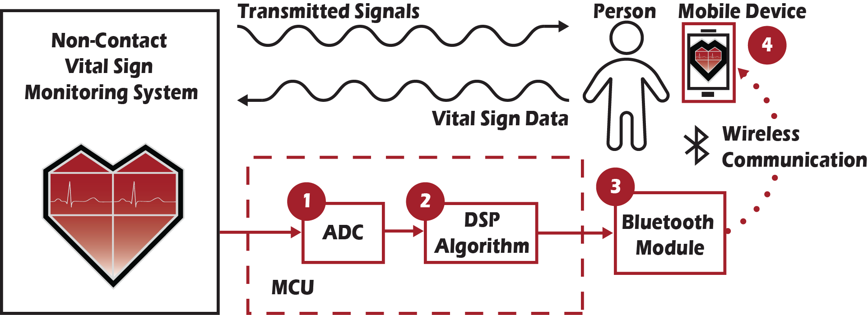

**Figure 1.** Block diagram showing the operation of the Mobile Non-Contact Vital Sign Monitoring System. The portions highlighted in red are within the scope of this project.

### Microcontroller with On-board Sigma-Delta ADC

The STM32F373VCT6 microcontroller, shown in Figure 2, was selected for the MNCVSM design because it has three 16-bit SDADCs, which allows use of up to 21 single channels or 11 differential channels to simultaneously process data, and a dedicated floating-point unit for calculations [12]. The 16-bit resolution for the SDADC allows for more accurate heart rate measurements to be achieved, and the dedicated floating-point unit is useful in incorporating signal processing algorithms. One of the channels of one of the SDADCs was configured in differential mode to convert the data received from the vital sign acquisition system. This microcontroller also includes a built-in UART interface that provides a connection point for the RN-41 Class 1 Bluetooth SMD module, which is used to transmit vital sign data to the mobile device at a baud rate of 115,200.

|  |  |
| --- | --- |
| https://lh4.googleusercontent.com/p1X-BVgt3tj9w-bSIswI-P1jLn9JijXIXvnrSXxquMtboeuMLYTg_Cx08PZRm3AiN23qGrRvEpjKyK2hxKv1FMosjyW5b_wtlwPe946CBQIWB5vDwA7BcwCujbjjau5UBcpAWeXw |  |

**Figure 2.** A top and bottom view of the STM32F373VCT6 microcontroller (left) and a top view of the STM32F373VCT6 evaluation board (right) [13], [14].

### Signal Processing for Extracting Respiration Rate and Heart Rate

This project used signal processing techniques to extract and update both the respiration rate and the heart rate approximately once every 35 seconds. The following steps were used to determine these vital signs:

1. The in-phase input is sampled at a rate of 1 sample per 0.032 seconds
2. At the update time, the last 1,024 samples (~33 seconds of time) are extracted as the sample
3. The sample is centered such that it has an average value of zero
4. The sample is transformed from the time domain to the frequency domain using a Fast Fourier Transform
5. The respiration rate is determined from by identifying the maximum value of the sample in the frequency domain within the range of frequencies corresponding to reasonable respiration rates (8 - 58 breaths per minute) [15], [16]
6. Within the range of frequencies corresponding to reasonable heart rates (3 times the respiration rate to 220 beats per minute), the following steps determine the heart rate: [17], [18]
   * Calculate a peak function value by using a peak-detection method that calculates how much greater the sample is at a particular frequency than the values of its neighbors within a window [19]
   * Take the difference between the maximum and minimum values within a window of frequencies around each frequency
   * Use the same peak-detection method to calculate the peak function value for the difference between the maximum and minimum values within a window around each sample in the frequency domain [19]
   * Determine the frequency corresponding to the maximum value of the product of these peak function values - it is the frequency of the heart rate

This signal processing algorithm worked well using 131,072 samples obtained using a sample rate of 1 sample per 0.001 seconds (~2 minutes and 11 seconds of time). The space required to allocate arrays for this algorithm did not fit within the memory of the MCU, so the algorithm implemented on the MCU uses only 1 sample per 0.032 seconds and 1,024 samples (~33 seconds of time). This algorithm has a precision of ~1.831 breaths/beats per minute, which means that the calculated vital sign rates are accurate within 1 breath/beat per minute. A design aspect that was not resolved is incorporating vital sign updates every second: the implemented algorithm only updates once every ~35 seconds.

### Bluetooth Communication

To establish a wireless connection between the MCU and the mobile application, an RN-41 Class 1 Bluetooth SMD module, shown in Figure 3, was used to channel messages between the two. This module connected to the MCU through a UART interface and to the mobile application through a Bluetooth connection. The two endpoints sent messages to each other with a sustained data rate up to 1.5 Mbps. Additionally, the data transferred wirelessly through a Bluetooth connection was naturally encrypted and, thus, achieved HIPAA compliance since the module was programmed to be secured by a password/PIN and blocked unknown devices.

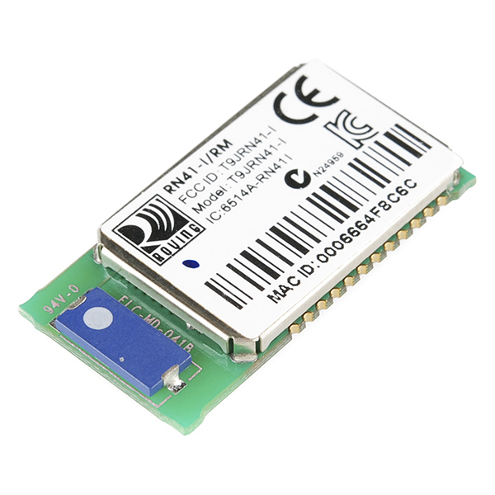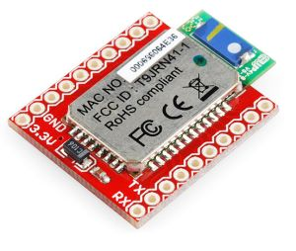

**Figure 3.** The RN-41 Class 1 Bluetooth SMD module (left) and the associated DIP breakout board (right) [20], [21].

During the system’s operation, two types of messages were sent from the MCU to the mobile application: status messages and data updates. Status messages include information about the state of the MCU (e.g. “Sampling input signals” or “Processing data”) that were shown to the user through the application. Data updates included two integer values corresponding to the calculated respiratory rate and heart rate formatted using the protocol shown in Figure 4. Upon receiving this message, the mobile application added the two values to their respective plots (the respiratory rate plot and the heart rate plot) in real-time.



**Figure 4.** Intra-system communication protocol where the message is constructed as a C char array with two colons that act as delimiting characters. The <respiratory rate> and <heart rate> are chars representing the calculated values.

### Mobile Application

The companion mobile application for the MNCVSM system was developed in Java using Android Studio and was designed to support Android devices of version 5.0/API level 2.1 or greater. Concurrently running processes within the application allowed the mobile device to simultaneously receive and process Bluetooth packets sent from the MCU and plot the processed data on the mobile device in real-time. Additional functionality allowed users to establish a password, save recorded vital sign information, and look through previously saved vital sign information. More details about the functionality and navigation of the user interface for the mobile application are included Appendix A.

The application was developed using a modular approach with various functions designed to be relatively independent of each other. This allowed unit testing to be performed prior to the application’s integration into the entire MCNVSM system. Saved data, such as the user’s password and vital sign information, was stored locally in an encrypted database in order to comply with HIPAA guidelines on the storage of protected health information. Figure 5 shows the relationships and interactions between software modules and other components in the MNCVSM system.

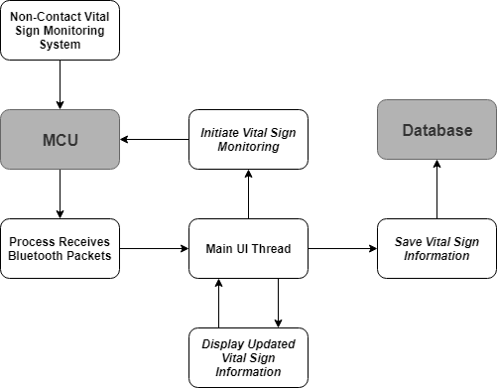

**Figure 5.** Block diagram showing the association between modules within the mobile application and the larger MNCVSM design. The white blocks are software modules within the application, and the grey blocks are a part of the larger MNCVSM system but are external to the mobile application.

The following third-party APIs were leveraged throughout the development of this application:

* CWAC-SafeRoom created by CommonsWare was used to encrypt and store vital sign data locally on the Android device [22]
* MPAndroidChart created by Philipp Jahoda was used to plot data received from the MCU in real-time [23]
* Android Bluetooth Library created by Omar Aflak was used to establish and maintain a Bluetooth connection between the mobile application and the mobile device [24]
* ViewPager tutorial created by Suleiman was used to create a set of tutorial screens for the application’s Help page [25]

### Future Work

Future work on this project will improve this design and enable it to be mass-produced and sold to the public. The MNCVSM Team recommends the following steps for proceeding further with the development of a mobile non-contact vital sign monitoring system:

* Conduct usability tests for the mobile application
* Utilize an MCU with more working memory to allow for a greater number of samples to be processed, which will yield more accurate measurements
* Incorporate a real-time operating system using multi-threading to allow for simultaneous signal acquisition and data processing and for vital sign updates to be provided every second
* Implement noise-reduction algorithms
* Design a printed circuit board for the MNCVSM device to remove unnecessary peripherals provided by the evaluation boards, to utilize traces instead of wires as connectors, and to reduce the size of the system

## Codes and Standards

1. The Health Insurance Portability and Accountability Act (HIPAA) enforces national standards for the security of electronic health-care related data. It features:
   * Restrictions on an individual’s health data, allowing only the patient and medical professionals assisting the individual to see it
   * Regulations for the online storage of medical information [26]

To ensure compliance with this law, The Wildcats Team is maintaining appropriate levels of protection when storing vital sign information on the user’s mobile device. This is the reason for using the Bluetooth communication protocol, incorporating time-outs for inactive application sessions, and encrypting data saved in the mobile device’s storage.

1. ANSI/AAMI ES60601-1:2005 governs the accuracy of medical instruments. It features a specification that the signal-to-noise ratio must be high enough to not mislead users [27]. This standard is enforced within Dr. Zhang’s Doppler radar system.
2. The Institutional Review Board (IRB) for Protection in Human Subjects in Research is a body that provides ethical and regulatory oversight of research involving human subjects. It features protection of research participants’ rights, welfare, and well-being [28]. Dr. Zhang and her graduate students have received IRB approval and training with a signal power level of 6 dBm. Outputs obtained by IRB-trained students were used while testing the design. Additionally, demonstrations of the entire system were only done with the oversight of IRB-trained students.
3. IEEE 802.15.1-2002 specifies wireless personal area network standards based on Bluetooth technology. It features:
   * Standard adaptations of the Bluetooth specifications
   * Specification of the physical layer and the Media Access Control for wireless connectivity [29]

Since the Bluetooth communication protocol provides fast, reliable, and secure communication, it allows for real-time transmission of vital sign information while providing HIPAA compliance. To make use of this protocol, a Bluetooth module is connected to the system’s MCU, and the mobile device running the companion application supports Bluetooth communication.

1. Android Open Source Project (AOSP) Java Code Style is a coding standard used for Java code contributions to official Android open source projects. It features:
   * Java language rules that define coding conventions
   * Java library rules that detail how changes may be made to existing libraries and prohibits the use of deprecated libraries
   * Java style rules that define stylistic guidelines to follow when writing code
   * Javatests style rules that define naming conventions to be used when creating test methods [30]

To ensure code readability and design reusability, the Wildcats Team is enforcing a consistent coding style by following the guidelines outlined under this coding convention.

## Constraints, Alternatives, and Tradeoffs

### Constraints

1. The ability to extract vital sign data from the Doppler radar vital sign monitoring system was constrained by the noise content of the signal. If the amplitude of the noise present in the signal was greater than or equal to the amplitude of the vital sign data to be extracted, the vital sign measurements could not be accurately obtained from the signal.
2. To sustain the amount of data that must be processed on the MCU, the on-board ADC must have had a minimum of 16-bit resolution, according to Dr. Zhang. If the ADC did not have sufficient resolution, it could not accurately collect the vital signal information to be communicated to the mobile application in real-time.
3. The MCU used in the final system (an STM32F373VCT6 microcontroller) had a flash memory size of 32 kB. This limited the amount of memory that the on-board signal processing algorithm could use, which affects the number of samples of the signal that can be stored and processed at a given time.

### Alternatives

1. Instead of using the Bluetooth wireless communication protocol, the Zigbee protocol could have been used. Zigbee offers wireless communication with a longer range, lower latency, and lower power consumption than Bluetooth; however, it has security flaws and a maximum communication bandwidth around 3% of the bandwidth provided by Bluetooth [31]. To ensure that the system remains compliant with HIPAA, the information sent by the MCU would need to provide encryption to compensate for the security flaws. Additionally, the MCU must ensure that the data rate does not exceed the lower communication bandwidth, which may require further data processing on the MCU to select what should be sent to the mobile device.
2. In addition to developing a mobile application for Android devices, an application for Apple devices could have been created. An Apple application, unlike an Android application, would need to be written using the Swift programming language and would need to be reviewed and approved by Apple before appearing in the App Store. The Apple application development environment allows for security and Bluetooth communication guarantees similar to those in the Android application development environment. In April 2018, around 54% of all active mobile devices used the Google Android operating system, while around 44% used Apple iOS [32]. The median income of iPhone users is roughly 40% greater than the median income of Android users [33]. Although an Apple application may be accessible to a similar number of users as an Android application, an Apple application would only be accessible to more economically advantaged users.

### Trade-offs

1. The signals from the non-contact system received by the MCU had to be processed to determine the user’s vital signs. This processing could have been performed entirely on-board the MCU, entirely within the mobile application, or partially in each. Processing the data entirely on the MCU allowed for only relevant vital sign data to be transferred to the mobile device. This processing depended heavily upon the capabilities of the MCU and what data throughput its ADC can handle. Processing the data entirely within the mobile application would have allowed for more a more detailed analysis of the signal data and would have taken advantage of the processing power of the mobile device. However, if the rate at which the raw data was transferred to the mobile device exceeded the bandwidth capabilities of the Bluetooth connection, then data could have been lost.
2. The accuracy of the calculated respiratory rate and heart rate produced by the on-board signal processing algorithm was affected by four factors: the number of samples being processed, the sampling rate, the length of time that samples are being acquired, and the size of the data type used to store each sample. The number of samples being processed for a single execution of the algorithm was directly proportional to the accuracy of the produced results. However, an increase in the number of samples also increased the amount of working memory that the algorithm required; for the system to operate, this could not exceed the amount of a memory available on the MCU. The sampling rate could be decreased in order to provide greater accuracy when the number of samples cannot be increased, but it came at the cost of requiring users to sit still for longer periods of time to obtain enough samples to run the signal processing algorithm. Finally, changing the data type used to store individual sample data (such as to a float or a short, in the C programming language) would allow more data to be stored at the cost of sample precision.
3. To allow users to view their vital sign history, the mobile application must save the vital sign information either locally or in cloud storage. Utilizing the device’s local storage allows immediate access to the vital sign history. However, the application is limited by the device’s storage capacity and must determine which data should be deleted if no more data space can be allocated. A cloud storage system allows a seemingly limitless storage capacity and can be accessed from multiple devices. Accessing vital sign history in cloud storage requires an internet connection and is limited by the bandwidth of that connection. Additionally, cloud storage services may require a service fee once the saved data exceeds a certain amount.

# Schedule, Tasks, and Milestones

Appendix B includes a Gantt Chart showing the tasks and timeline for this project. Here is a breakdown of the project contributions for each team member:

* Nydrel Jack:
  + Designed an encrypted SQLite database for mobile application
    - Wrote SQL queries for accessing (storage and retrieval) the local database
    - Developed classes and objects for storing user specific and vital sign information
  + Developed mobile application modules to perform the following tasks:
    - Plotting received vital sign data in real-time
    - Starting, pausing, and resuming signal acquisition
    - Save vital sign information from capture screen
    - Filter vital sign history by type (heart and respiratory rate) or date
  + Configured the SDADC for the MCU
    - Connected SMA cables from the analog system to the appropriate pins on the STM32F373VCT6 Evaluation Board
    - Wrote code to convert analog signals using the SDADC’s differential mode
  + Managed source code control for the MCU and the mobile application
    - Created GitHub repositories for the MCU and the mobile application
    - Helped team members configure version control systems for their software development environments
    - Maintained latest working version of each software component (MCU, mobile app, etc.)
  + Operated and tested the full system
* Arianne Perez:
  + Designed the brand, logo, and user interface for the mobile application
  + Implemented some aspects of the user interface design, including icons and colors
  + Helped program basic navigation within the History screen
  + Researched information for the MCU and assisted in both gathering vital sign data and initializing the MCU
  + Communicated with the Senior Design Lab Assistants to obtain parts that were not contained on the order form, but were necessary for completing the project
  + Maintained the project website
  + Designed and printed the Capstone Expo poster
* Chelsi Taylor:
  + Maintained hardware for the MNCVSM system
    - Ordered and purchased parts through the Senior Design Lab
    - Soldered components
    - Performed hardware system integration and connection
  + Researched and tested components and integrated development environments
  + Assisted with the initialization of the SDADC on the MCU
  + Configured the Bluetooth module and tested communication between two endpoints
  + Established a connection between the MCU and the Bluetooth module
  + Sent messages from the SCADC on the MCU to the Bluetooth-connected mobile device
  + Assisted with the design of the Capstone Design Expo poster
  + Designed Capstone Design Expo uniforms
* Ethan Vargas:
  + Implemented user interface design and navigation for the mobile application
  + Developed mobile application modules to perform the following tasks:
    - Navigate to each screen
    - Allow users to log into and out of the mobile application
    - Automatically log out of the mobile application due to device inactivity
    - Allow the user to start, pause, and resume signal acquisition
    - Plot received vital sign data
    - Allow users to view saved vital sign information
    - Allow users to view tutorial slides to help them use the system
    - Allow the user to connect to and disconnect from a paired Bluetooth device
    - Handle messages received through a Bluetooth connection
    - Allow users to change the application settings
  + Configured the Bluetooth module and tested communication between two endpoints
  + Established a connection between the MCU and the Bluetooth module and tested sending messages from the MCU to the Bluetooth-connected mobile device
  + Developed a messaging protocol to allow the Bluetooth-connected mobile device to interpret received data
  + Optimized and scaled down the signal processing algorithm so that it could fit within the available memory on the MCU
  + Created a working version of the system that takes in an analog signal and sends a calculated respiratory and heart rate to the mobile device
  + Tested the system using a function generator and confirmed that the expected signal values were observed and that the expected respiratory and heart rates were calculated
  + Connected the system to the non-contact vital sign monitoring system and performed tests to confirm accuracy
  + Created documentation to help future users install and run the project’s code
* Nathanael Williams:
  + Developed signal processing algorithm
  + Tested signal processing algorithm on a PC using pre-recorded vital sign data
  + Confirmed accuracy of vital sign information when modifying the signal processing algorithm to fit within the available memory on the MCU
  + Confirmed accuracy of signal processing algorithm when testing on the MCU
  + Proofread and edited the Project Proposal, Proposal Presentation, Capstone Expo Poster, and Final Report

These were the main tasks associated with this project and the relative difficulty of each:

* MCU configuration and data acquisition: This task was the most difficult portion of the project. The chosen MCU has an ambiguous reference material and few examples of how it can be configured. Additionally, the non-contact vital sign monitoring system is susceptible to more noise than a function generator, which was used to test the system, so accuracy was lost when the MCU was connected to the entire system.
* Signal processing algorithm development: This task was not particularly difficult, but it was time-consuming. Testing of potential signal processing algorithms required a lot of trial-and-error to ensure accuracy of the algorithm when using pre-recorded vital signs. The most challenging part of this task was reducing the space allocation necessary for the algorithm so that it could be incorporated on the MCU while maintaining some level of accuracy.
* Wireless communication: This task was easy to accomplish since team members had previous experience with similar embedded systems. The Bluetooth communication from the mobile device and the UART communication from the MCU were already working, so the Bluetooth module simply needed to be configured properly.
* Mobile application development: This task was time-consuming but not very difficult due to team members’ previous experience with developing mobile applications for Android devices.
* System testing: This task was easy to accomplish since each individual component was tested for correct behavior before the entire system was connected. Because of this, the tests performed on the entire system were only done to view results and quantify the inaccuracies inherent in the radar signal acquisition, rather than ensuring that the system is working as intended.

# Project Demonstration

## Prototype Testing

The individual components of the design were tested separately first to ensure that specifications are satisfied. The following is a list of these components and the associated tests performed to ensure correct behavior.

* Microcontroller
  + A sample application provided by the manufacturer that showed the SDADC conversion of an analog input was used to confirm that analog signals were being received by user-identified pins.
  + When sending values through the a UART interface, an oscilloscope was used to confirm that data was being sent from the expected pins before connecting that pin to the Bluetooth module.
* Signal Processing Algorithm
  + Pre-recorded vital sign data was processed on a PC to ensure accurate signal processing techniques for vital sign extraction.
  + Pre-recorded vital sign data was processed on a PC to ensure accurate code optimization and scaling techniques used for processing the signal.
* Bluetooth Module
  + The Bluetooth communication between the module and the mobile device was tested by connecting the Bluetooth module to an Mbed MCU that sent messages through a UART connection to the Bluetooth module.
  + The UART communication between the MCU and the mobile device was tested by connecting to the Bluetooth module using a serial Bluetooth communication application that received messages from the Bluetooth module that were, in turn, received from the MCU through a UART connection.
* Mobile Application
  + The functionality of the mobile application was tested both using emulators within Android Studio and with physical Android devices to ensure proper operation.
  + The user interface and navigation were tested by having test users go through each screen of the application and interact with everything available on the screen. This ensured meaningful navigation and identified sources of error.
  + The Bluetooth communication was tested by using serial Bluetooth communication application from both a PC and another mobile device to send messages to the mobile device running the application. All expected types of data were sent and then plotted real-time on the mobile application. The mobile application attempted to connect to and disconnect from various paired Bluetooth devices repeatedly to ensure that it would be able to connect to the Bluetooth module.

After verifying that each component was working as intended, all parts were integrated into the full system. This prototype was then tested using the following steps:

* Pre-recorded vital sign data was processed by the MCU to ensure accurate vital sign extraction.
* A function generator was used to simulate a real signal. It was connected to the MCU to ensure accurate signal acquisition and processing.
* The MCU was connected to the radar system, and a user was seated in front of the system. A data sampling application provided by Zongyang Xia, Dr. Zhang’s Ph.D. student, that showed a high-resolution plot for the signal was run at the same time as the MCU’s data acquisition and processing in order to compare the results received on the mobile device with the observed signals.
* A user’s vital signs were calculated for several minutes, and then the user was asked to do jumping jacks for 60 seconds. This light exercise elevated the user’s respiration and heart rates, as expected.

## Final Demonstration

The demonstration of this design involved setting up the non-contact vital sign monitoring system and selecting volunteer users for monitoring. Each user was asked to sit down in a chair in front of the radar system and remain still. During operation of the system, real-time updates of the user’s respiration and heart rate were displayed on the Android mobile device running the MNCVSM mobile application and duplicated on a PC. The demonstration proceeded as follows:

1. A volunteer user was seated in front of the radar system.
2. An Android mobile device running the MNCVSM mobile application connected to the MCU through Bluetooth, and the mobile device interface was duplicated on a PC.
3. The user was instructed to remain still while vital sign information was collected.
4. Vital sign detection was initiated through the mobile application.
5. Current rates and graphs of the user’s vital signs were displayed in the user interface of the mobile application in real-time.
6. Navigation through the mobile application showed vital sign history and other features within the mobile application.

## Project Information

More information about this project including Technical Review Papers, the Project Proposal, the Proposal Presentation and the Capstone Design Expo Poster can be found on the MNCVSM Team’s website: http://ece4012y201902.ece.gatech.edu/spring/sd19p49/

# Marketing and Cost Analysis

## Marketing Analysis

The demographic for this design consists of emergency rescue teams, hospitals (particularly burn units and neonatal intensive care units), doctor’s offices, assisted-living and retirement homes, pharmacies, and individuals who suffer from chronic illnesses or want to monitor their vital signs on their own. Currently, there are no Doppler radar non-contact vital monitoring systems commercially available, though such devices exist. SENSIOTEC developed an Impulse Radio Ultra-Wideband sensor using Doppler radar non-contact vital sign monitoring technology. However, this sensor is currently not widely available due to its cost and use of specialized hardware [3], [11].

Despite the lack of commercially available Doppler radar non-contact vital sign monitoring technologies, there are other commercially available non-contact vital sign monitoring technologies, including the under-the-bed non-contact sensor developed by muRata [7]. The under-the-bed sensor PCB module with Wi-Fi, which includes data transmission comparable to the Wildcats Team’s design, is about $198.88 per unit [9]. The main advantage the MNCVSM system has over the available technology is that it provides users immediate access to vital sign information on a mobile application.

## Cost Analysis

The parts needed to develop a prototype of the MNCVSM system included an MCU, an MCU evaluation board, a Bluetooth module, a Bluetooth module evaluation board, and 12 SMA connectors. The total cost for all parts used in developing the MNCVSM system was $557.87, which is detailed in Table 5. The amount the Wildcats Team spent from the budget supplied by the Senior Design Lab was $425.20, which is shown in Table 6. Additional MCUs and the SPBT3.0DP1 Bluetooth modules were ordered for testing, but the SPBT3.0DP1 Bluetooth modules and the Bluetooth evaluation board could not be used after the evaluation board was damaged. The RN-41 Bluetooth Module Breakout board was provided by the Senior Design Lab, and the jack connectors coaxial cables, and coaxial connectors were provided by Dr. Zhang and Zongyang Xia. Table 7 shows the costs associated with all of the parts utilized in the final prototype of the MNCVSM device.

**Table 5.** Cost of All Parts Used in Developing a Prototype

|  |  |  |  |
| --- | --- | --- | --- |
| **Product Description** | **Quantity** | **Unit Price** | **Cost** |
| STM32F373VCT6 Microcontroller [13] | 5 | $6.42 | $32.10 |
| STM32F373VCT6 Evaluation Board [34] | 1 | $248.75 | $248.75 |
| SPBT3.0DP1 Bluetooth Classic Module [35] | 5 | $19.42 | $97.10 |
| SPBT3.0DP1 Bluetooth Classic Module Evaluation Board [36] | 1 | $47.25 | $47.25 |
| RN-41 Bluetooth Module Breakout Board [21] | 1 | $59.95 | $59.95 |
| CON-SMA-EDGE-S Jack Connector [37] | 4 | $1.74 | $6.96 |
| CCSMA-MM-086-8 Coaxial Cable [38] | 4 | $10.68 | $42.72 |
| 132169 Coaxial Connector [39] | 4 | $5.76 | $23.04 |
| **Total** | | | **$557.87** |

**Table 6.** Cost of Parts Charged to the Senior Design Budget

|  |  |  |  |
| --- | --- | --- | --- |
| **Product Description** | **Quantity** | **Unit Price** | **Cost** |
| STM32F373VCT6 Microcontroller [13] | 5 | $6.42 | $32.10 |
| STM32F373VCT6 Evaluation Board [34] | 1 | $248.75 | $248.75 |
| SPBT3.0DP1 Bluetooth Classic Module [35] | 5 | $19.42 | $97.10 |
| SPBT3.0DP1 Bluetooth Classic Module Evaluation Board [36] | 1 | $47.25 | $47.25 |
| **Total** | | | **$425.20** |

**Table 7.** Cost of Parts Used in Prototype

|  |  |  |  |
| --- | --- | --- | --- |
| **Product Description** | **Quantity** | **Unit Price** | **Cost** |
| STM32F373VCT6 Microcontroller [13] | 1 | $6.42 | $6.42 |
| STM32F373VCT6 Evaluation Board [34] | 1 | $248.75 | $248.75 |
| RN-41 Bluetooth Module Breakout Board [21] | 1 | $59.95 | $59.95 |
| CON-SMA-EDGE-S Jack Connector [37] | 4 | $1.74 | $6.96 |
| CCSMA-MM-086-8 Coaxial Cable [38] | 4 | $10.68 | $42.72 |
| 132169 Coaxial Connector [39] | 4 | $5.76 | $23.04 |
| **Total** | | | **$413.52** |

The annual salary for a typical Electrical/Computer Engineer with a 40-hour work week is about $70,000. An engineer who receives two weeks of holidays and two weeks of paid time-off per year works 48 weeks each year; this translates to an hourly labor cost of $36.46 [40]. Table 8 shows the labor time and cost per engineer on the MNCVSM Team. Each engineer worked a total of 175 hours for an individual labor cost of $6,380.21. This includes meetings, research and design, assembly and testing, and writing reports. The total labor time and cost for five engineers are 875 hours and $31,901.04, respectively.

**Table 8.** Labor Costs per Engineer on the MNCVSM Team

|  |  |  |
| --- | --- | --- |
|  | **Total Hours** | **Cost** |
| Meetings | 15 | $546.88 |
| Research | 10 | $364.58 |
| Design | 110 | $4,010.42 |
| Assembly and Testing | 10 | $364.58 |
| Reports | 30 | $1,093.75 |
| **Total** | **175** | **$6,380.21** |

Assuming 30% fringe benefits of labor and 120% overhead on materials/labor/fringe benefits, the total development cost of the prototype of the MNCVSM system and mobile application is $92,464.29, as shown in Table 9.

**Table 9.** Total Development Costs

|  |  |
| --- | --- |
| **Development Component** | **Cost** |
| Parts | $557.87 |
| Labor | $31,901.04 |
| Fringe Benefits, 30% of Labor | $9,570.31 |
| **Subtotal** | $42,029.22 |
| Overhead, 120% of Material, Labor, & Fringe Benefits | $50,435.07 |
| **Total** | **$92,464.29** |

The MNCVSM Team approximates that 5,000 units will be produced and sold at a unit price of $300 over a period of five years. To implement a production-ready design and to eliminate the costs associated with the evaluation board for the MCU, the breakout board for Bluetooth module, and the SMA connectors, a custom PCB can be designed to replace those parts and provide the same functionality. The MNCVSM Team estimates that the custom PCB will cost $20 per unit. Table 10 details the costs associated with the custom PCB and the other parts that need to be purchased for producing 5,000 units.

**Table 10.** Equipment Costs for Producing 5,000 Units

|  |  |  |  |
| --- | --- | --- | --- |
| **Product Description** | **Quantity** | **Unit Price** | **Cost** |
| STM32F373VCT6 Microcontroller [13] | 5,000 | $3.64 | $18,200.00 |
| SPBT3.0DP1 Bluetooth Classic Module [35] | 5,000 | $13.42 | $67,100.00 |
| Custom PCB Design | 5,000 | $20.00 | $100,000.00 |
| **Total** | | | **$185,300.00** |
| **Cost Per Unit** | | | **$37.06** |

The sales expense, for marketing and advertising, will be 7% of the final sale price, which translates to an expense of $21. The expected revenue for producing and selling 5,000 units at a price of $300 is $1,500,000, which will yield a profit of $93.67 per unit and a total profit of $468,340 over the five-year period. The percent of revenue that is profit for each unit sold is 31.22%. The production costs, profit, and selling price of the final product are displayed in Table 11.

**Table 11.** Selling Price and Profit per Unit

|  |  |
| --- | --- |
| **Description** | **Cost** |
| Parts | $37.06 |
| Fabrication Labor | $10.00 |
| Assembly Labor | $10.00 |
| Testing Labor | $10.00 |
| **Total Labor** | **$30.00** |
| Fringe Benefits, 30% of Labor | $9.00 |
| **Subtotal** | **$76.06** |
| Overhead, 120% of Material, Labor, & Fringe Benefits | $91.27 |
| **Subtotal, Input Costs** | **$167.33** |
| Sales Expense | $21.00 |
| Amortized Development Costs | $18.00 |
| **Subtotal, All Costs** | **$206.33** |
| Profit | $93.67 |
| **Selling Price** | **$300.00** |

# Conclusion

The Wildcats Team successfully completed the objective of receiving, processing, and transmitting vital sign data to a mobile application to be displayed in real-time. The current status of this project is that the MNCVSM system updates a user’s heart and respiration rate once every 35 seconds, accurate to within 0.916 breaths/beats per minute, and displays the values in a continuous line chart on a mobile device.

While testing the communication between the SPBT3.0DP1 Bluetooth Classic Module (the original Bluetooth module being used in the system) and the MCU, the Bluetooth module was damaged because it was connected to a power supply with a greater voltage difference than it can handle. While trying to remove the module from the evaluation board to replace it with another one, the evaluation board was damaged and deemed unusable. Since this was the only evaluation board that the Wildcats Team purchased, an alternative Bluetooth module, the RN-41 Class 1 Bluetooth Module, was used, instead. This module offered the same bandwidth across a Bluetooth connection as the previous Bluetooth module and provided a UART interface that could be used with the MCU.

If this project were repeated, it would be beneficial for the team working on the project to select an MCU with more documentation than the STM32F373VCT6 microcontroller has or to dedicate at least three team members to work on the MCU development. During most of the project’s duration, the Wildcats Team had only two members working on the MCU, trying to interpret its limited documentation; this resulted in the MCU development portion of the project falling behind schedule and becoming the bottleneck for testing the system as a whole.

Another factor that would be useful for future teams working on this project to consider is determining the memory capacity of the MCU early on in the design process. This way, the team could focus on designing a signal processing algorithm specifically for the MCU that will be used during implementation. The Wildcats Team did not use this strategy for developing such an algorithm and had to modify their original algorithm to fit on the MCU, which caused the results to lose both accuracy and precision.

During the project demonstration at the Georgia Institute of Technology Spring 2019 Capstone Design Expo, the MNCVSM system yielded results that fell between the ranges of the normal respiratory rate (12-20 breaths per minute) and resting heart rate (60-80 beats per minute) for a human, but most of the time the results were not within this window. This was likely due to external noise and reflections collected by the system when it was set up at the Capstone Design Expo. Many other projects were also present on that hallway contributing electrical noise, which may have negatively impacted the signal-to-noise ratio of the acquired signal. Continued work on this project will likely require noise cancellation at the source or demonstration in an area where external noise can be controlled.

# Leadership Roles

These are the leadership roles that each team member had during the duration of this project:

* Nydrel Jack: Mobile Application Developer, Microcontroller Developer, Database Designer, Version Control Manager
* Arianne Perez: UX/UI Designer, Webmaster, Poster Designer, Senior Design Lab Liaison
* Chelsi Taylor: Hardware Developer and Implementation Engineer, Uniform Designer
* Ethan Vargas: Team Leader, Mobile Application Developer, Microcontroller Developer, Lead Programmer, Expo Coordinator, Team Liaison
* Nathanael Williams: Signal Processing Algorithm Developer and Programmer, Documentation Coordinator, Final Editor, Technical Support

# References

[1] Z. Xia, M. Shandhi, O. Inan, and Y. Zhang, “Non-Contact Sensing of Seismocardiogram Signals Using Microwave Doppler Radar,” *IEEE Sensors Journal*, vol. 18, no. 14, pp. 5956-5964, July 2018.

[2] Z. Lasater, J. Rosker, A. Elsabbagh, A. Genutis, and A. Renuart, “Non-Contact Analysis of Health-Informatics via Observable Metrics,” May 3, 2018.

[3] T. Hall, D. Lie, T. Nguyen, J. Mayeda, P. Lie, J. Lopez, and R. Banister, “Non-Contact Sensor for Long-Term Continuous Vital Signs Monitoring: A Review on Intelligent Phased-Array Doppler Sensor Design,” *Sensors*, vol. 17, no. 11, pp. 2632-2651, Nov. 2017.

[4] DPP Mag, “Monochrome Digital Cameras,” *Gear*, May 4, 2015. [Online]. Available: https://www.digitalphotopro.com/gear/professional-cameras/monochrome-capture/. [Accessed: Apr. 30, 2019].

[5] J. Lagasse, “Continuous monitoring tools could save hospitals $20,000 per bed, report says,” *Healthcare IT News*, Aug. 4, 2016. [Online]. Available: https://www.healthcareitnews.com/  
news/continuous-monitoring-tools-could-save-hospitals-20000-bed-report-says. [Accessed: Apr. 30, 2019].

[6] muRata, SCA10H datasheet, Sep. 2015 [Revised Aug. 2016].

[7] muRata, SCA11H datasheet, Sep. 2015 [Revised Dec. 2015].

[8] “SCA10H-D01-112 Murata Electronics North America,” *Digi-Key*. [Online]. Available: https://www.digikey.com/product-detail/en/murata-electronics-north-america/SCA10H-D01  
-112/490-16645-ND/7595506. [Accessed: Apr. 30, 2019].

[9] “SCA11H-A01-036 Murata Electronics North America,” *Digi-Key*. [Online]. Available: https://www.digikey.com/product-detail/en/murata-electronics-north-america/SCA11H-A01  
-036/490-14344-ND/6605973. [Accessed: Apr. 30, 2019].

[10] C. Li, J. Ling, J. Li, and J. Lin, “Accurate Doppler Radar Noncontact Vital Sign Detection Using the RELAX Algorithm,” *IEEE Transactions on Instrumentation and Measurement*, vol. 59, no. 3, pp. 687–695, Mar. 2010.

[11] F. Zhao, M. Li, Z. Jiang, J. Z. Tsien, and Z. Lu, “Camera-Based, Non-Contact, Vital-Signs Monitoring Technology May Provide a Way for the Early Prevention of SIDS in Infants,” *Frontiers in Neurology*, vol. 7, Dec. 2016.

[12] STMicroelectronics, STM32F373xx datasheet, Jun. 2012 [Revised Jun. 2016].

[13] “STM32F373VCT6 STMicroelectronics,” *Digi-Key*. [Online]. Available: https://www.digikey.com/products/en/integrated-circuits-ics/embedded-microcontrollers/685  
?k=STM32F373VCT6%20Microcontroller. [Accessed: Apr. 30, 2019].

[14] “STM32373C-EVAL, Evaluation Board for ARM Cortex-M4 core-based STM32F373VCT6 Microcontroller,” *ARROW*. [Online]. Available: https://www.arrow.com/en/reference-designs/  
stm32373c-eval-evaluation-board-for-arm-cortex-m4-core-based-stm32f373vct6  
-microcontroller/43de37e731b357c717cd2eff9d04a81e. [Accessed: Apr. 30, 2019].

[15] MedlinePlus, “Rapid shallow breathing,” Apr. 1, 2019. [Online]. Available: https://medlineplus.gov/ency/article/007198.htm. [Accessed: Apr. 30, 2019].

[16] Reference.com, “What is the Normal Breathing Rate After Exercise?” [Online]. Available: https://www.reference.com/health/normal-breathing-rate-after-exercise-64c17bd529ac6745. [Accessed: Apr. 30, 2019].

[17] New Health Advisor, “Charts of Normal Resting and Exercising Heart Rate,” Apr. 4, 2019. [Online]. Available: https://www.newhealthadvisor.com/Normal-Heart-Rate-Chart.html. [Accessed: Apr. 30, 2019].

[18] M. Lee, “Relationship Between Heart Rate & Breathing Rate.” [Online]. Available: https://healthyliving.azcentral.com/relationship-between-heart-rate-breathing-rate-3710.html. [Accessed: Apr. 30, 2019].

[19] G. Palshikar, “Simple Algorithms for Peak Detection in Time-Series,” Jan. 2019. Available: https://www.researchgate.net/publication/228853276_Simple_Algorithms_for_Peak_Detection_in_Time-Series. [Accessed: Apr. 30, 2019].

[20] “Bluetooth SMD Module - RN-41 (v6.15),” *sparkfun*. [Online]. Available: https://www.sparkfun.com/products/12575. [Accessed: Apr. 30, 2019].

[21] “Bluetooth DIP Module - Roving Networks RN-41 (Microchip),” *MicroController Pros*. [Online]. Available: https://microcontrollershop.com/product_info.php?products_id=  
2807&gclid=EAIaIQobChMIn8felpfl4QIVxY2zCh2TXwYeEAQYBCABEgLVPvD_BwE. [Accessed: Apr. 30, 2019].

[22] CommonsWare, “CWAC-SafeRoom,” Apr. 28, 2019. [Online]. Available: https://github.com/  
commonsguy/cwac-saferoom. [Accessed: Apr. 30, 2019].

[23] P. Jahoda, “MPAndroidChart,” Apr. 27, 2019. [Online]. Available: https://github.com/PhilJay/  
MPAndroidChart. [Accessed: Apr. 30, 2019].

[24] O. Aflak, “Android Bluetooth Library,” Apr. 28, 2019. [Online]. Available: https://github.com/  
OmarAflak/Bluetooth-Library. [Accessed: Apr. 30, 2019].

[25] Suleiman, “Onboarding with Android ViewPager: The Google Way,” May 24, 2017. [Online]. Available: https://blog.iamsuleiman.com/onboarding-android-viewpager-google-way/. [Accessed: Apr. 30, 2019].

[26] Office for Civil Rights, “HIPAA for Professionals,” *HHS.gov*, June 16, 2017. [Online]. Available: https://www.hhs.gov/hipaa/for-professionals/index.html. [Accessed: Apr. 30, 2019].

[27] *Medical electrical equipment - Part 1: General requirements for basic safety and essential performance*, ANSI/AAMI ES60601-1:2005, Jan. 17, 2012.

[28] “Institutional Review Board,” *National Institute of Environmental Health Sciences*, Oct. 29, 2018. [Online]. Available: https://www.niehs.nih.gov/about/boards/irb/index.cfm. [Accessed: Apr. 30, 2019].

[29] *IEEE Standard for Telecommunications and Information Exchange Between Systems - LAN/MAN - Specific Requirements - Part 15: Wireless Medium Access Control (MAC) and Physical Layer (PHY) Specifications for Wireless Personal Area Networks (WPANs)*, IEEE 802.15.1-2002, May 14, 2002.

[30] “AOSP Java Code Style for Contributors,” *android.com*. [Online]. Available: https://source.android.com/setup/contribute/code-style. [Accessed: Apr. 30, 2019].

[31] M. Christiano, “ZigBee vs Bluetooth and Bluetooth Smart,” *ALL ABOUT CIRCUITS*, Sep. 9, 2015. [Online]. Available: https://www.allaboutcircuits.com/technical-articles/zigbee-vs  
-bluetooth-and-bluetooth-smart/. [Accessed: Apr. 30, 2019].

[32] “Subscriber share held by smartphone operating systems in the United States from 2012 to 2018,” *statista*. [Online]. Available: https://www.statista.com/statistics/266572/market-share  
-held-by-smartphone-platforms-in-the-united-states/. [Accessed: Apr. 30, 2019].

[33] A. Lella, “iPhone Users Earn Higher Income, Engage More on Apps than Android Users,” *comscore*, Aug. 14, 2014. [Online]. Available: https://www.comscore.com/Insights/  
Infographics/iPhone-Users-Earn-Higher-Income-Engage-More-on-Apps-than-Android-Users. [Accessed: Apr. 30, 2019].

[34] “STM32373C-EVAL STMicroelectronics,” *Digi-Key*. [Online]. Available: https://www.digikey.com/products/en?keywords=STM32F373VCT6%20Evaluation%20Board. [Accessed: Apr. 30, 2019].

[35] “STMicroelectronics SPBT3.0DP1,” *Mouser Electronics*. [Online]. Available: https://www.mouser.com/ProductDetail/STMicroelectronics/SPBT30DP1?qs=  
%2Fha2pyFadugu3zrSGUuhuBx5n3mkJTxx5BQ1K0g%2FODtgeS%2FNLZoqpg%3D%3D&utm_source=octopart&utm_medium=aggregator&utm_campaign=511-SPBT3.0DP1&utm  
_content=STMicroelectronics. [Accessed: Apr. 30, 2019].

[36] “STEVAL-BTDP1 STMicroelectronics,” *Digi-Key*. [Online]. Available: https://www.digikey.com/products/en?keywords=SPBT3.0DP1%20Bluetooth%20Classic  
%20Module%20Evaluation%20Board. [Accessed: Apr. 30, 2019].

[37] “CON-SMA-EDGE-S RF Solutions,” *Digi-Key*. [Online]. Available: https://www.digikey.com/  
products/en?keywords=CON-SMA-EDGE-S%20Jack%20Connector. [Accessed: Apr. 30, 2019].

[38] “CCSMA-MM-086-8 Crystek Corporation,” *Digi-Key*. [Online]. Available: https://www.digikey.com/products/en?keywords=CCSMA-MM-086-8%20Coaxial%20Cable. [Accessed: Apr. 30, 2019].

[39] “Amphenol RF Division 132169,” *Digi-Key*. [Online]. Available: https://www.digikey.com/  
product-detail/en/amphenol-rf-division/132169/ACX1242-ND/1011919. [Accessed: Apr. 30, 2019].

[40] S. Adams. “The College Degrees With The Highest Starting Salaries,” *Forbes*, Sep. 20, 2013. [Online]. Available: https://www.forbes.com/sites/susanadams/2013/09/20/the-college  
-degrees-with-the-highest-starting-salaries/#37b0382b5c0d. [Accessed: Apr. 30, 2019].

# Appendix A - Mobile Application User Interface

The mobile application has four screens providing different functionality for the user: Login, Capture, History, and Help. When opening the application, the Login screen will be displayed. This screen allows users to create a new password or login using a previously set password. If a password has already been set up and the user creates a new one, all previously saved vital sign information is deleted from the device. This is done to comply with HIPAA guidelines and to ensure that users cannot see another person’s vital sign information. Figure A.1 shows the operation of the Login screen.

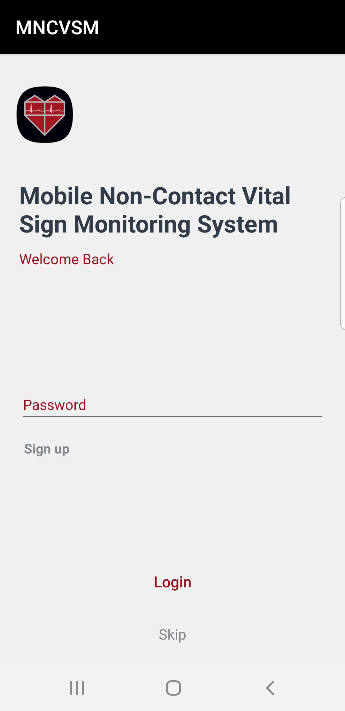 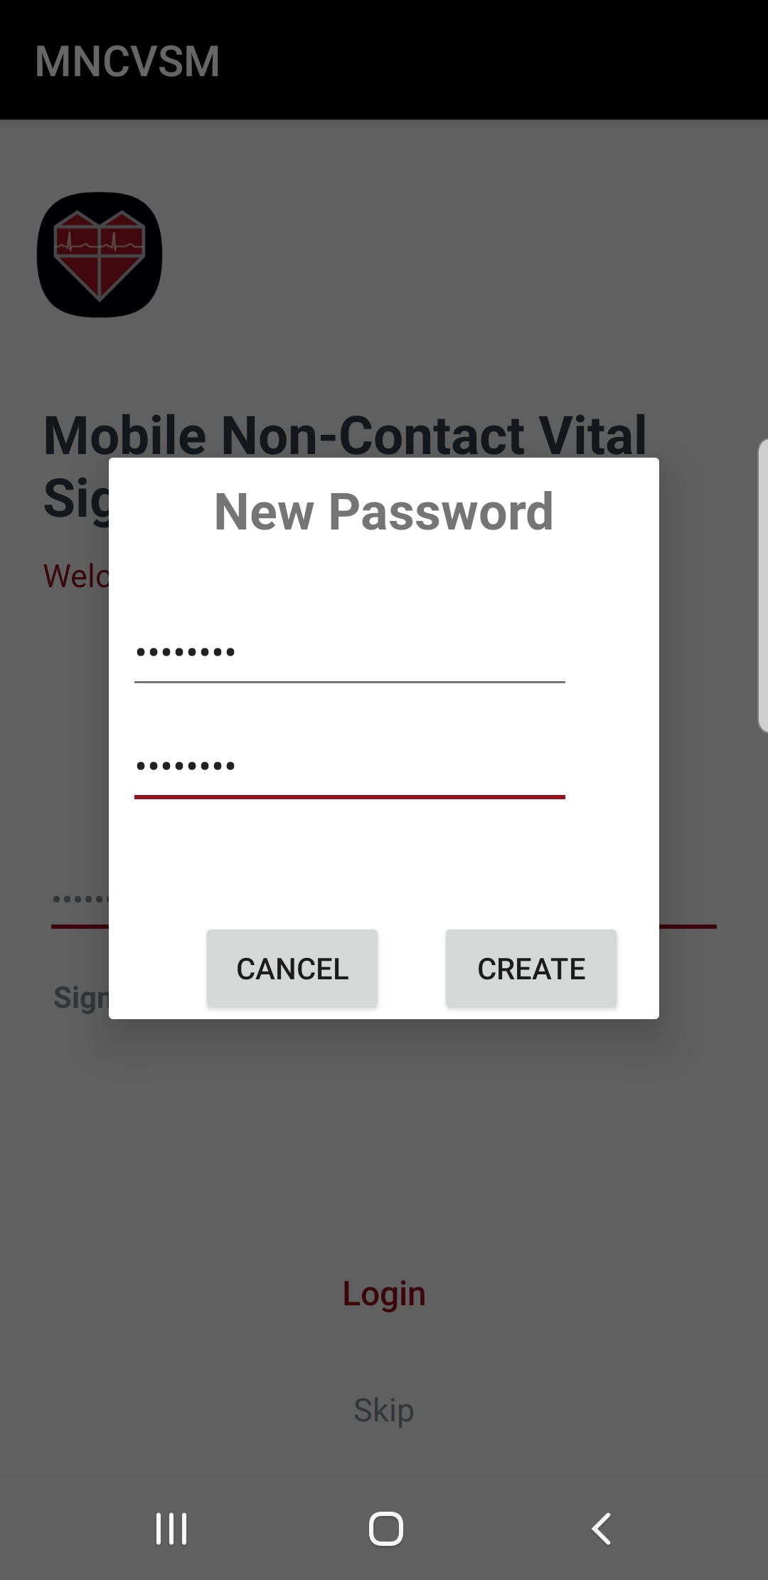 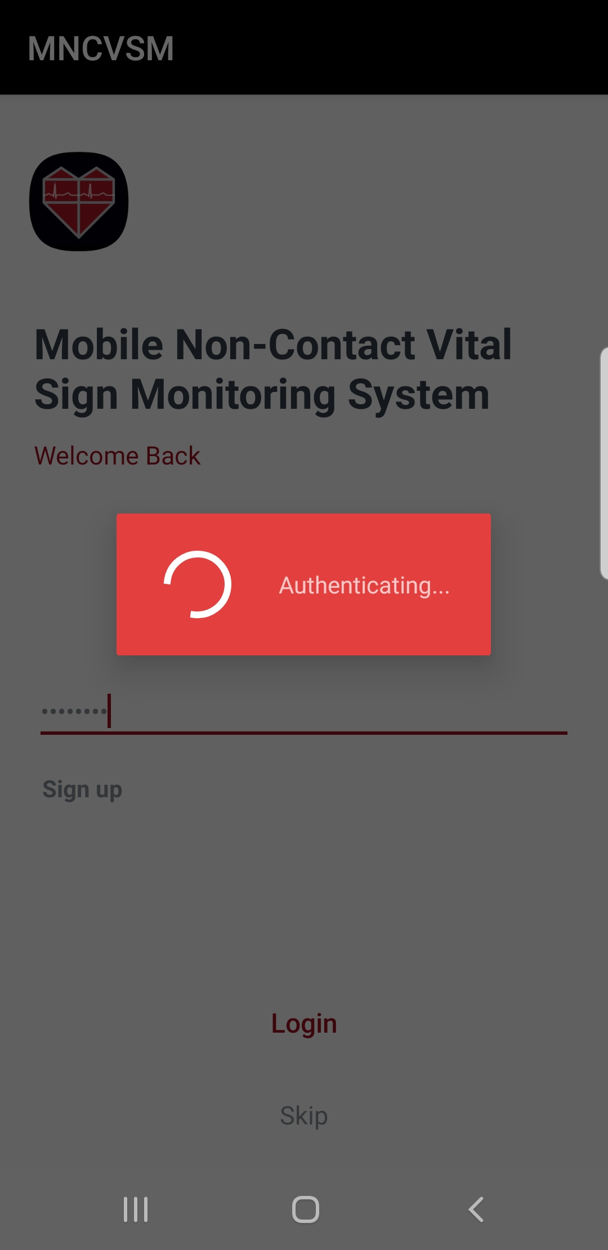

**Figure A.1.** Mobile application screens showing the Login screen functionality.

Upon successfully logging into the application, the Capture screen is displayed. Once logged in, a user will be able to freely navigate between the Capture, History, and Help screens. The Capture screen allows users to establish a Bluetooth connection with the Bluetooth module of the non-contact vital sign monitoring system (it has already been paired with this system), start and pause the real-time plotting of processed vital sign signals, save plotted vital sign signals, and change application settings (this includes the display of vital sign data and the name of the Bluetooth module that is being connected to the device). Figure A.2 displays the features of the Capture screen.

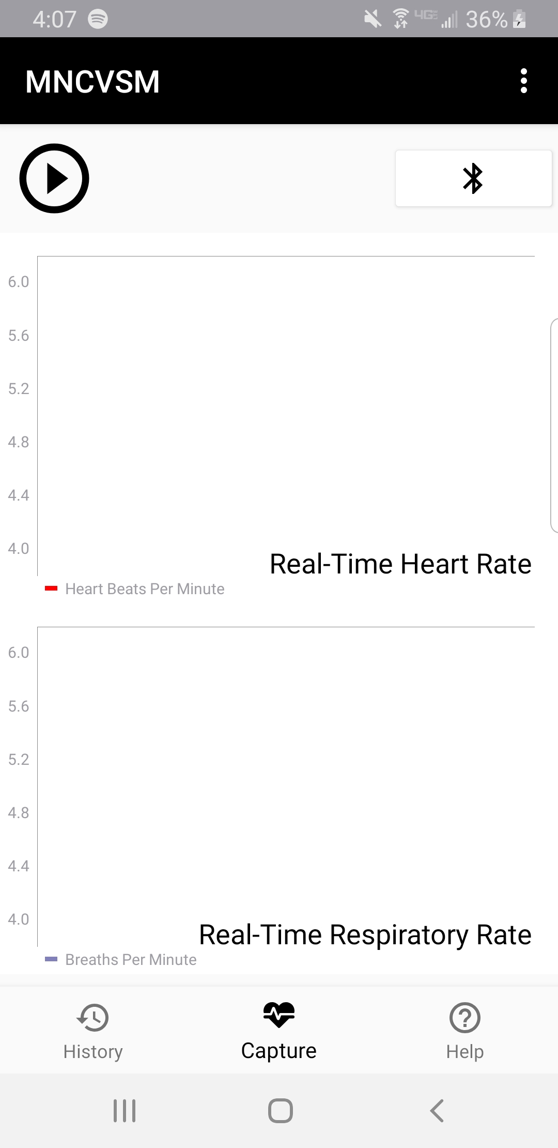 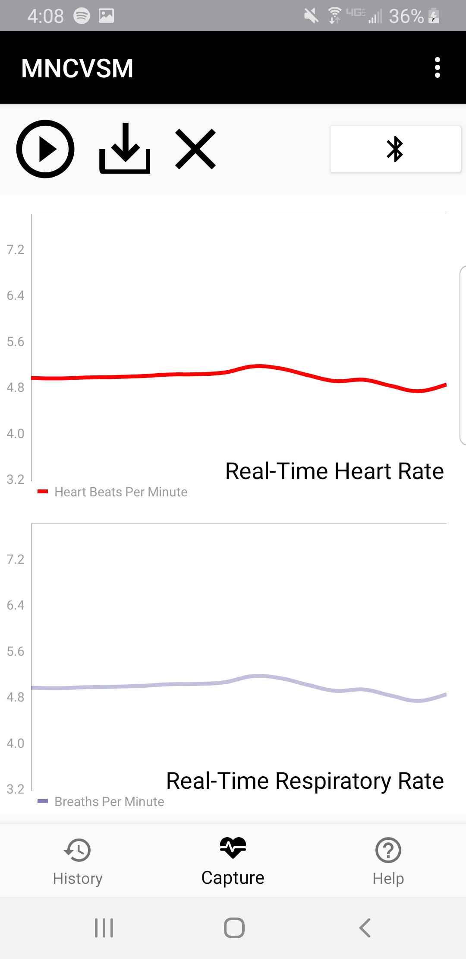 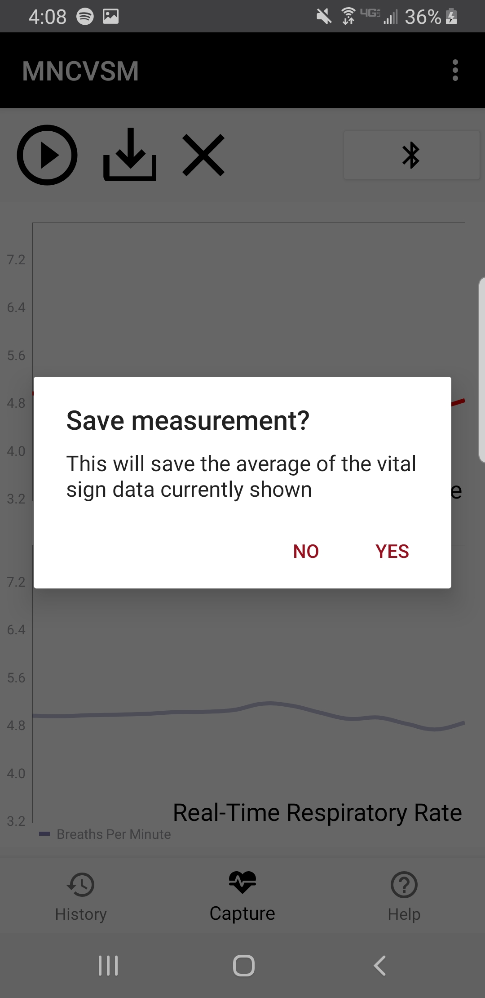

**Figure A.2.** Mobile application screens showing the Capture screen functionality.

The History screen, shown in Figure A.3, allows users to view vital sign information that has previously been saved through the application. Users can navigate to tabs showing either their captured heart rates or respiration rates within the last week or the last month. The recorded value for each of these rates is the average of the last ten data points plotted before the save was made.

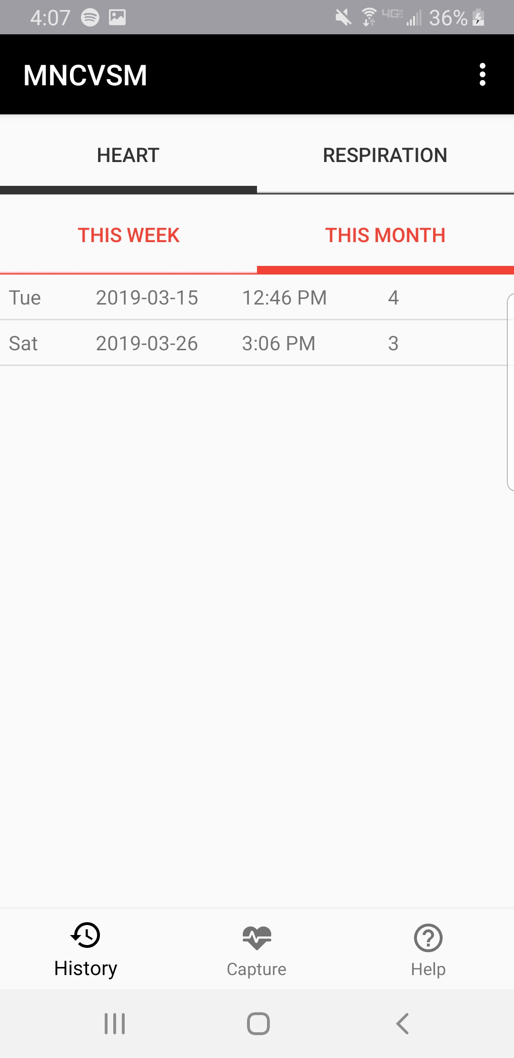 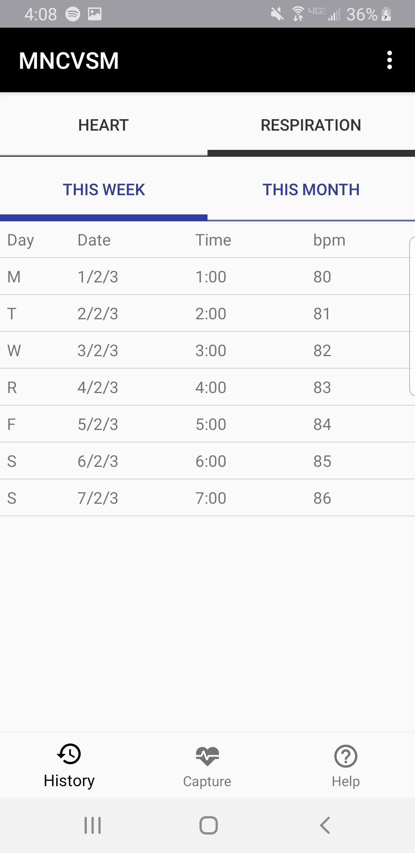

**Figure A.3.** Mobile application screens showing the History screen functionality.

The Help screen will inform the user of how to use the mobile application with the rest of the non-contact vital sign monitoring system. When this screen is selected, the user can slide through five tutorial slides explaining the process of recording vital sign data. When finished reading through these slides, the user will be brought back to the Capture screen. Figure A.4 shows various pages of the Help screen.

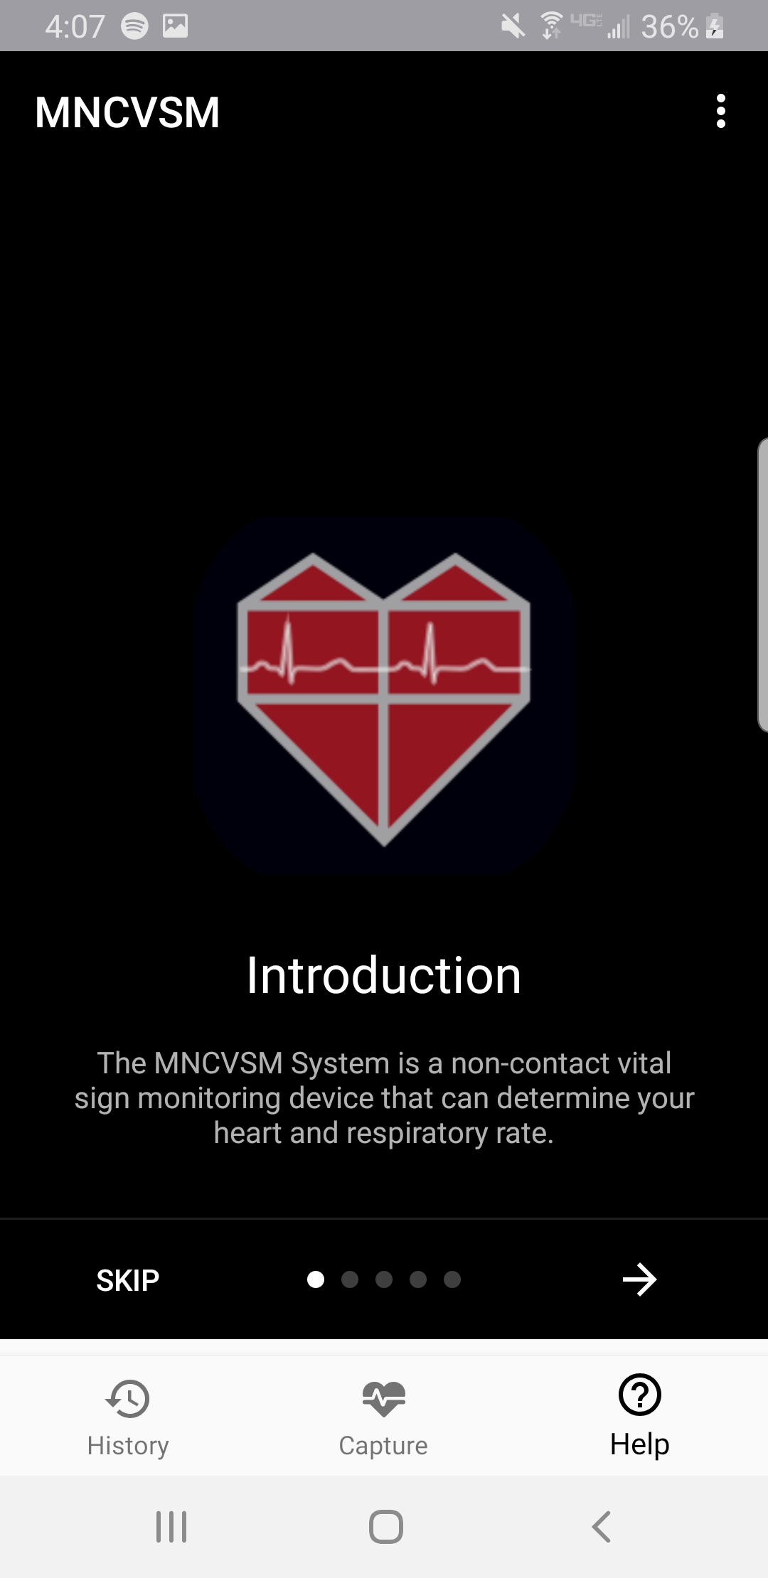 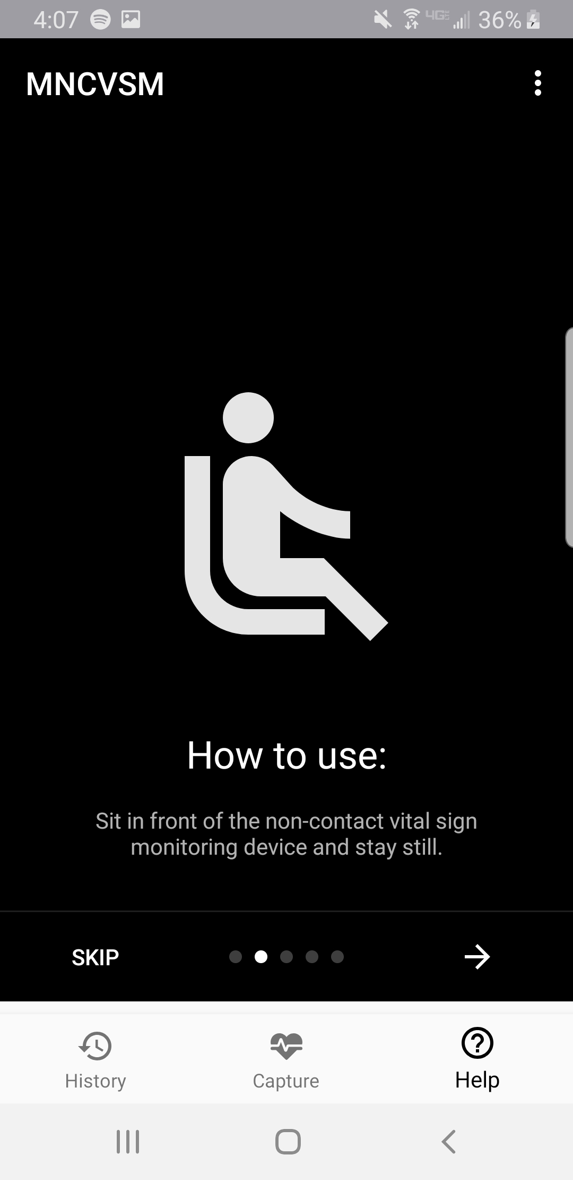 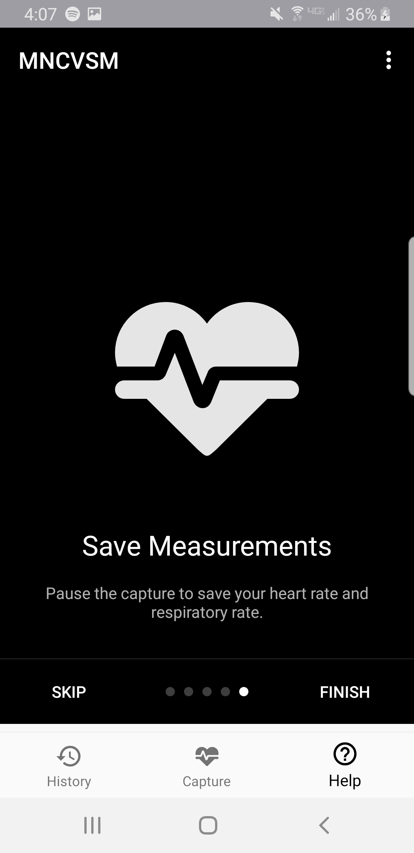

**Figure A.4.** Mobile application screens showing the Help screen functionality.

If the application has been minimized on the mobile device for two minutes or if the Android device has been put to sleep for two minutes, an Inactivity screen will be displayed. This screen will ask the user to once again provide the password to the application. If the correct password is provided, the screen that the user was most recently using will be shown. A user who does not know the password (or does not wish to resume activity), may sign out and be returned to the Login screen. The Inactivity screen is displayed in Figure A.5.

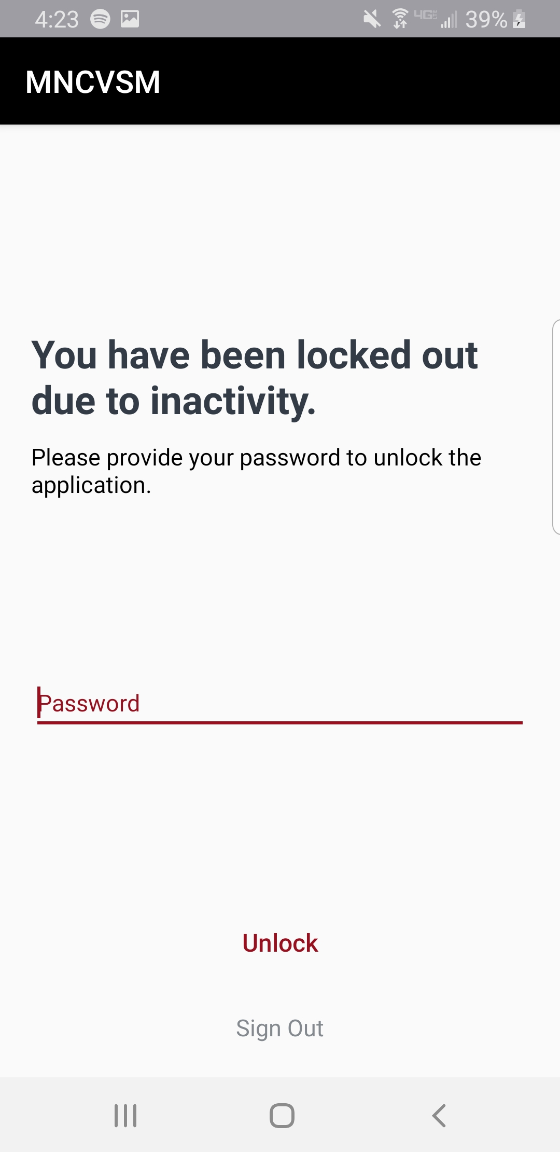

**Figure A.5.** Mobile application screen showing the Inactivity screen.

# Appendix B - Comprehensive Gantt Chart

|  |  |  |  |  |  |
| --- | --- | --- | --- | --- | --- |
|  | 10/29 | 11/5 | 11/12 | 11/19 | 11/26 |
| **Phase I (Fall 2018) -- Planning** |  |  |  |  |  |
| **Research** |  |  |  |  |  |
| **Codes and standards for project** |  |  |  |  |  |
| **MCU options, processing capability of MCUs** |  |  |  |  |  |
| **Signal processing methods for vital sign signals** |  |  |  |  |  |
| **Communication between MCU and mobile device** |  |  |  |  |  |
| **Bluetooth capability of MCUs** |  |  |  |  |  |
| **Mobile device options for mobile application, focus on processing capability** |  |  |  |  |  |
| **Deliverables** |  |  |  |  |  |
| **Project Summary Form (Draft)** |  |  |  |  |  |
| **Project Summary Form (Final)** |  |  |  |  |  |
| **Design Proposal** |  |  |  |  |  |
| **Individual Design Notebooks (Phase I)** |  |  |  |  |  |

|  |  |  |  |  |  |  |  |  |  |  |  |  |  |  |  |
| --- | --- | --- | --- | --- | --- | --- | --- | --- | --- | --- | --- | --- | --- | --- | --- |
|  | 1/7 | 1/14 | 1/21 | 1/28 | 2/4 | 2/11 | 2/18 | 2/25 | 3/4 | 3/11 | 3/18 | 3/25 | 4/1 | 4/8 | 4/15 |
| **Phase II (Spring 2019) -- Implementation** |  |  |  |  |  |  |  |  |  |  |  |  |  |  |  |
| **Preliminary Tasks (Everyone)** |  |  |  |  |  |  |  |  |  |  |  |  |  |  |  |
| **Proposal Presentation (January 15, 2019)** |  |  |  |  |  |  |  |  |  |  |  |  |  |  |  |
| **Acquire pre-recorded vital sign signals for testing** |  |  |  |  |  |  |  |  |  |  |  |  |  |  |  |
| **Complete order form (Chelsi)** |  |  |  |  |  |  |  |  |  |  |  |  |  |  |  |
| **Order and receive parts** |  |  |  |  |  |  |  |  |  |  |  |  |  |  |  |
| **MCU Data Acquisition and Processing** |  |  |  |  |  |  |  |  |  |  |  |  |  |  |  |
| **Determine data processed on MCU versus on mobile device** |  |  |  |  |  |  |  |  |  |  |  |  |  |  |  |
| **Design algorithm to extract vital signs (Nathanael)** |  |  |  |  |  |  |  |  |  |  |  |  |  |  |  |
| **Test and update algorithm on PC using pre-recorded vital signs (Nathanael)** |  |  |  |  |  |  |  |  |  |  |  |  |  |  |  |
| **Clean up signal processing code (Nathanael)** |  |  |  |  |  |  |  |  |  |  |  |  |  |  |  |
| **Convert signal processing code to C for testing on the MCU (Ethan, Nathanael)** |  |  |  |  |  |  |  |  |  |  |  |  |  |  |  |
| **Configure MCU for testing (Nydrel, Arianne, Chelsi, Ethan)** |  |  |  |  |  |  |  |  |  |  |  |  |  |  |  |
| **SDADC configuration and testing (Nydrel, Chelsi)** |  |  |  |  |  |  |  |  |  |  |  |  |  |  |  |
| **Wireless Communication** |  |  |  |  |  |  |  |  |  |  |  |  |  |  |  |
| **Develop Bluetooth pairing between two mobile devices (Ethan)** |  |  |  |  |  |  |  |  |  |  |  |  |  |  |  |
| **Research MCU and Bluetooth module (Chelsi)** |  |  |  |  |  |  |  |  |  |  |  |  |  |  |  |
| **Update firmware on Bluetooth module (Chelsi)** |  |  |  |  |  |  |  |  |  |  |  |  |  |  |  |
| **Establish connectivity between Bluetooth module and mobile device (Chelsi,  Ethan)** |  |  |  |  |  |  |  |  |  |  |  |  |  |  |  |
| **Test wireless communication channel (Chelsi, Ethan)** |  |  |  |  |  |  |  |  |  |  |  |  |  |  |  |
| **Establish connectivity between Bluetooth module and MCU evaluation board  (Chelsi)** |  |  |  |  |  |  |  |  |  |  |  |  |  |  |  |
| **Communicate processed or raw data from MCU to mobile device (Nydrel, Chelsi,  Ethan)** |  |  |  |  |  |  |  |  |  |  |  |  |  |  |  |

|  |  |  |  |  |  |  |  |  |  |  |  |  |  |  |  |
| --- | --- | --- | --- | --- | --- | --- | --- | --- | --- | --- | --- | --- | --- | --- | --- |
|  | 1/7 | 1/14 | 1/21 | 1/28 | 2/4 | 2/11 | 2/18 | 2/25 | 3/4 | 3/11 | 3/18 | 3/25 | 4/1 | 4/8 | 4/15 |
| **Phase II (Spring 2019) -- Implementation** |  |  |  |  |  |  |  |  |  |  |  |  |  |  |  |
| **Mobile Application** |  |  |  |  |  |  |  |  |  |  |  |  |  |  |  |
| **Determine Android version to use for mobile application** |  |  |  |  |  |  |  |  |  |  |  |  |  |  |  |
| **Design user interface for mobile device (Arianne)** |  |  |  |  |  |  |  |  |  |  |  |  |  |  |  |
| **Implement user interface design (Arianne, Ethan)** |  |  |  |  |  |  |  |  |  |  |  |  |  |  |  |
| **Develop login module (Ethan)** |  |  |  |  |  |  |  |  |  |  |  |  |  |  |  |
| **Incorporate device inactivity feature (Ethan)** |  |  |  |  |  |  |  |  |  |  |  |  |  |  |  |
| **Implement sign-in and sign-out functionality (Ethan)** |  |  |  |  |  |  |  |  |  |  |  |  |  |  |  |
| **Update mobile application navigation (Ethan)** |  |  |  |  |  |  |  |  |  |  |  |  |  |  |  |
| **Develop module to plot continuous data readings from accelerometer (Nydrel)** |  |  |  |  |  |  |  |  |  |  |  |  |  |  |  |
| **Develop module to locally store data on mobile device (Ethan)** |  |  |  |  |  |  |  |  |  |  |  |  |  |  |  |
| **Design encrypted database for storing vital sign information (Nydrel)** |  |  |  |  |  |  |  |  |  |  |  |  |  |  |  |
| **Develop module to start, pause, and resume stop vital sign acquisition (Nydrel)** |  |  |  |  |  |  |  |  |  |  |  |  |  |  |  |
| **Develop module to save vital sign data (Nydrel)** |  |  |  |  |  |  |  |  |  |  |  |  |  |  |  |
| **Clean up version control and comment mobile application code (Nydrel, Ethan)** |  |  |  |  |  |  |  |  |  |  |  |  |  |  |  |
| **Incorporate database storage with vital sign history (Nydrel, Ethan)** |  |  |  |  |  |  |  |  |  |  |  |  |  |  |  |
| **Finalize mobile application navigation including adding safeguards (Ethan)** |  |  |  |  |  |  |  |  |  |  |  |  |  |  |  |
| **Compile companion mobile application** |  |  |  |  |  |  |  |  |  |  |  |  |  |  |  |
| **Testing (Entire System -- MCU + Wireless Communication + Mobile App)** |  |  |  |  |  |  |  |  |  |  |  |  |  |  |  |
| **Send function generator data through MCU to mobile device (Chelsi)** |  |  |  |  |  |  |  |  |  |  |  |  |  |  |  |
| **Test on-board algorithm using function generator** |  |  |  |  |  |  |  |  |  |  |  |  |  |  |  |
| **Use real-time vital sign signals of volunteer subjects, show on mobile device** |  |  |  |  |  |  |  |  |  |  |  |  |  |  |  |

|  |  |  |  |  |  |  |  |  |  |  |  |  |  |  |  |  |  |  |
| --- | --- | --- | --- | --- | --- | --- | --- | --- | --- | --- | --- | --- | --- | --- | --- | --- | --- | --- |
|  | 1/7 | 1/14 | 1/21 | 1/28 | 2/4 | 2/11 | 2/18 | 2/25 | 3/4 | 3/11 | 3/18 | 3/25 | 4/1 | 4/8 | 4/15 | 4/22 | 4/29 | 5/6 |
| **Phase III (May 2019) -- Reports and Presentation** |  |  |  |  |  |  |  |  |  |  |  |  |  |  |  |  |  |  |
| **Individual Design Notebooks (Phase II and III)** |  |  |  |  |  |  |  |  |  |  |  |  |  |  |  |  |  |  |
| **Project Website** |  |  |  |  |  |  |  |  |  |  |  |  |  |  |  |  |  |  |
| **Compile important results, figures, information, etc.** |  |  |  |  |  |  |  |  |  |  |  |  |  |  |  |  |  |  |
| **Design Expo Poster** |  |  |  |  |  |  |  |  |  |  |  |  |  |  |  |  |  |  |
| **Final Presentation (April 23, 2019)** |  |  |  |  |  |  |  |  |  |  |  |  |  |  |  |  |  |  |
| **Final Report** |  |  |  |  |  |  |  |  |  |  |  |  |  |  |  |  |  |  |