Mobile Non-Contact Vital Sign Monitoring

ECE4011 Senior Design Project

Section A05, Wildcats
Project Advisor, Dr. Ying Zhang

Nydrel Jack, njack7@gatech.edu
Arianne Perez, aperez71@gatech.edu
Chelsi Taylor, ctaylor63@gatech.edu
Ethan Vargas, evargas30@gatech.edu
Nathanael Williams, nwilliams68@gatech.edu

Submitted

January 8, 2019
Table of Contents

Executive Summary iv

- Introduction 1

  - Objective 1
  - Motivation 2
  - Background 3
    - Camera-Based Non-Contact Vital Sign Monitoring 3
    - Under-the-Bed Noncontact Sensors 4
    - Doppler-Radar Non-Contact Vital Sign Monitoring 4

- Project Description and Goals 5

- Technical Specifications 6

- Design Approach and Details 7

  - Design Approach 7
    - Microcontroller with On-board ADC 8
    - Mobile Application 9
    - User Interface 10
  - Codes and Standards 11
  - Constraints, Alternatives, and Tradeoffs 13
    - Constraints 13
    - Alternatives 14
    - Trade-offs 15

- Schedule, Tasks, and Milestones 16

- Project Demonstration 16

  - Prototype Testing 16
6.2 Final Demonstration 17

- Marketing and Cost Analysis 17

  - Marketing Analysis 17
  - Cost Analysis 18

- Current Status 21

- References 22

Appendix A 25

Appendix B 28

Appendix C 29

Executive Summary
Many people living with chronic illnesses or disabilities that interfere with everyday activities need to have their vital signs monitored on a regular basis; this is often done by a relative or an assigned caregiver. A system that can accurately measure someone’s vital signs without physical contact can provide autonomy to people who need constant monitoring and is beneficial for at-home health care, biomedical monitoring, and search-and-rescue applications. To conveniently provide results to the user, it is necessary for the system to wirelessly communicate health information in real-time to a partner application on a mobile device.
The Mobile Non-Contact Vital Sign Monitoring Team will design a mobile application that interfaces with a non-contact system that can monitor vital signs using microwave Doppler-radar and will implement an algorithm to interpret these signals on-board the connected microcontroller unit (MCU) [1]. The application will wirelessly communicate with the MCU through a Bluetooth connection to present the user with vital sign information on a mobile device in real-time. This mobile application and the accessibility it provides for a non-contact vital sign monitoring system will enable those who need regular monitoring to more easily record their vital signs and will put less pressure on family members and caregivers to provide constant supervision. Additionally, this device can be used by medical professionals to more easily monitor people with conditions that would otherwise make recording vital signs difficult, such as burn victims. The expected outcome of the design is a completed companion Android mobile application and a fully functional MCU that can interface with a non-contact vital sign monitoring system and will cost approximately $388.63.
Mobile Non-Contact Vital Sign Monitoring
1. Introduction
The Mobile Non-Contact Vital Sign Monitoring (MNCVSM) Team is requesting $388.63 to develop a mobile application that will use Bluetooth to receive vital sign data acquired from a Doppler radar-based vital sign monitoring system and processed in real-time using a microcontroller unit (MCU) with an on-board Analog-to-Digital Converter (ADC).
  - Objective
The purpose of this project is to design and build a prototype for a system that receives, processes, and transmits vital sign data to a mobile application to be displayed in real-time. The vital sign data containing heart rate and respiration rate information will be acquired from a Doppler-based non-contact vital sign monitoring system. This system produces a carrier signal from a microwave signal generator. The MCU will transmit the processed data to a mobile application through a universal asynchronous receiver/transmitter (UART) connection to a Bluetooth module. The mobile application will display the vital sign data in a user-friendly interface.

  - Motivation
The motivation for creating the MNCVSM system is to provide access to heart and respiration rate measurements for those who are at-risk for health problems detectable by changes in vital signs, those involved in search-and-rescue applications, caregivers, and individuals who simply wish to measure their heart and/or respiration rate without the limitations of current vital sign measuring systems. By implementing a user-friendly mobile application for the continuous non-contact vital sign monitoring system, the likelihood of detection of health problems, such as cardiac events, will be increased for non-medically trained individuals. Current health monitoring systems require medical professionals to accurately measure an individual’s heart and/or respiration rates. Additionally, these systems often require contact and do not provide continuous monitoring. This may dissuade individuals from obtaining accurate, continuous measurements and, thus, limiting the early detection of life-threatening conditions [2].
This project will build upon the efforts of the Non-Contact Analysis of Health-Informatics via Observable Metrics (NAHOM) Team, a previous Electrical and Computer Engineering Senior Design team at the Georgia Institute of Technology. However, instead of using an external ADC connected to an MCU and processing the vital sign data via a DSP algorithm on a connected portable computer (PC), like the NAHOM system, the MNVCSM system will use an MCU with an on-board ADC to perform the DSP and communicate the processed data to a mobile device. This will produce a more accessible, more portable, and more cost-effective design as it eliminates the requirement for an ADC evaluation board, which is priced at $124.99 [2].

  - Background
The scope of NAHOM’s project included utilizing an MCU, an external ADC, and a PC interface to capture, transfer, process, and display vital sign information. The Doppler-radar transceiver used to generate the raw analog signal containing information about the user’s vital signs was developed by Dr. Zhang and her graduate students. The NAHOM Team’s design uses an external ADC and sends the digital signal to the MCU using a Serial Peripheral Interface. The MCU is also used to send configuration commands to the ADC; from there, the signal is sent to a PC using a UART peripheral and the signal is processed using C#. The NAHOM Team also developed an interface to display and save vital sign data on a PC. Currently, there are three major methods for non-contact vital sign monitoring: with cameras, with sensors, and with Doppler-radar.
    - Camera-Based Non-Contact Vital Sign Monitoring
Researchers at Rice University were able to determine the heart rate of a subject using a monochrome camera and a photoplethysmographic estimation algorithm they developed by measuring the change of hemoglobin and oxyhemoglobin in any area of a subject’s face [3]. Although the study needs more data to prove that this method is viable for long-term monitoring, the results, with respect to the technology used to conduct the study, are promising. With the average cost of a monochrome camera ranging from $7,000 to over $40,000 in an age where the price of technology decreases rapidly as new technology is developed, this technology could replace the monitoring equipment in hospitals that ranges from $20,000 to $30,000 per setup [4], [5].

    - Under-the-Bed Non-contact Sensors
muRata, an electronics company, has developed an accelerometer-based ballistocardiographic (BCG) signal sensor that is attached underneath a patient’s bed to measure vital signs continuously [3]. It works by capturing the vibrations of the bed caused by a patient’s heartbeat, respiration, and body movement using an ultra-sensitive accelerometer and a microcontroller to process the information and determine the measurements [3]. The sensor includes a printed circuit board (PCB) module that contains the accelerometer and the microcontroller for BCG algorithm processing; it also includes a PCB module with the bonus of WiFi connectivity for ease of integration [6], [7]. The modules are sold in units with prices ranging from $106.82 to $137.84 per unit for the PCB module and $170.92 to $198.88 per unit for the PCB module with WiFi [8], [9].
    - Doppler-Radar Non-Contact Vital Sign Monitoring
Microwave Doppler-radar has gained popularity in wireless sensing applications, including volume change sensing, life detection, and cardiopulmonary monitoring; this has increased interest in using it for non-contact vital sign monitoring [10]. The Doppler-radar first transmits a radio-frequency continuous wave signal, and then captures the signal once it has been reflected off the human body [3]. After the reflected signal is amplified and down-converted, the human heartbeat and respiration rates are identified by processing the baseband signal using advanced signal processing techniques [10]. SENSIOTEC, a biomedical company, has developed an Impulse Radio Ultra-Wideband sensor using this technology, but it is not widely available due to its cost and use of specialized hardware [3], [11].

2. Project Description and Goals
The main goal of this project is to develop a mobile application that can initialize vital sign acquisition and display the user’s vital signs in real-time. The vital sign data will be retrieved from a non-contact vital sign monitoring system that uses Doppler-based radar to acquire the vital sign signal. After the data has been processed, it will be communicated to a mobile device via Bluetooth; from there, the mobile application will calculate and display the vital signs in both numerical and graphical format. The target users for this product are medical professionals who want to view and track patients’ vital signs and non-medically trained individuals who want to personally monitor their vital signs. Another goal of this project is to make this product accessible to the public at a market price of no more than $300.00. The main features of this design include:
- Microcontroller
  - Uses DSP of the received vital sign signals
  - Uses Bluetooth wireless communication to transmit information from the MCU to the mobile device
- Mobile Application
  - Initializes acquisition of the vital sign signal
  - Allows the user to create an account for saving and sending vital sign data
  - Allows the user to navigate vital sign information through an easy-to-interpret interface
  - Displays summary statistics and continuous real-time graphs of vital sign information
  - Saves and records historical vital sign information for the user in a local database
- Technical Specifications
There are four distinct components that are relevant to the MNCVSM project: the MCU, the MCU’s on-board ADC, the Bluetooth module, and the mobile application. Specifications for these components are listed in Tables 1 through 4. The MCU needs to contain at least two ADCs that can work simultaneously with minimum resolutions of 16 bits each to work with the non-contact vital sign monitoring system while achieving a desirable signal-to-noise ratio (SNR) that will not mislead users. A dedicated floating point unit is required on the MCU to handle DSP computations.
Table 1. Microcontroller Unit Specifications
Feature | Specification
SPI Data Rate | >= 24 kB/s
Data Processing Ability | dedicated floating point unit
Power Supply | < 5.0 V
Size | no specific size; should be considered portable

Table 2. ADC Specifications
Feature | Specification
Bit Resolution | >= 16 bits
Number of Channels | 3 channels
Sampling Rate | >= 1000 samples/channel/second
Power Supply | < 5.0 V
Size | no specific size; should be considered portable

Table 3. Bluetooth Module Specifications
Feature | Specification
Data Throughput | >= 1 Mbps
Inter-Device Range | >= 20 meters
Bandwidth | 2.4 GHz
Power Supply | < 5.0 V
Peak Power Consumption | <= 80 mA
Size | should be smaller than the STM32F373VCT6 evaluation board

Table 4. Mobile Application and Device Specifications
Feature | Specification
Operating System | Android 5.0 or greater
Wireless Communication | Bluetooth capable
Display and Plotting Ability | real-time plotting of analyzed data

- Design Approach and Details
  - Design Approach
The MNCVSM system will utilize an MCU with an on-board ADC to perform all of the DSP, use Bluetooth to transmit signal data to a mobile device, and develop an Android application that allows users to initiate vital sign capture, view waveforms, and save/send vital sign data. A block diagram that shows the overall operation of the MNCVSM system and identifies what is within the scope of this project is shown in Figure 1.
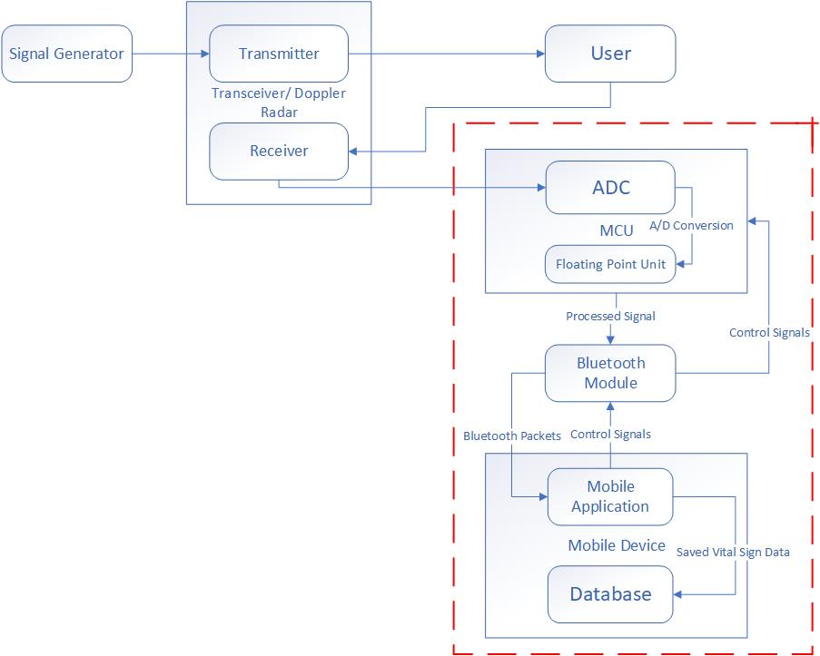
Figure 1. System block diagram of the MNCVSM system. The red border outlines what is within the scope of the project.

    - Microcontroller with On-board ADC
The STM32F373VCT6 microcontroller, shown in Figure 2, was selected for the MNCVSM design because it has three 16-bit Sigma Delta ADCs, which allows use of up to 21 single channels or 11 differential channels to simultaneously process data, and a dedicated FPU for calculations [12]. After the data is processed, the STM32F373VCT6 evaluation board will provide additional capabilities for data transfer such as UART, USB, and HDMI. A top view of the evaluation board is shown in Figure 2. Another reason for selecting this microcontroller is to access to the built-in UART interface that provides a connection point for the SPBT3.0DP1 Bluetooth Classic module and evaluation board, which will be used to transmit vital sign data to the mobile device.

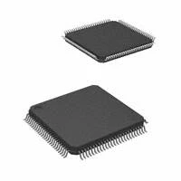 | 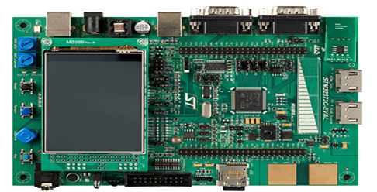
Figure 2. A top and bottom view of the STM32F373VCT6 microcontroller (left) and a top view of the STM32F373VCT6 evaluation board (right).

    - Mobile Application
The mobile application will be developed using Java and will be available for use on Android devices. Android 5.0/API level 21 will be the lowest version of the Android operating system that the MNCVSM application will be designed to support. Separate functions will be written to initiate vital sign monitoring from a mobile device, receive and process Bluetooth packets sent from the MCU, plot the processed data on the mobile display, and save the processed data points. The application and database used for storing vital sign data will be developed using a modular approach, which will allow unit tests to be created for each function before integrating them into a complete application and, later, the entire MNCVSM system. An encrypted local database will be used to store data and account information. If a local database cannot be used for data storage, another option is to use a cloud database. Figure 3 encapsulates the interaction between software modules in the MNCVSM system.
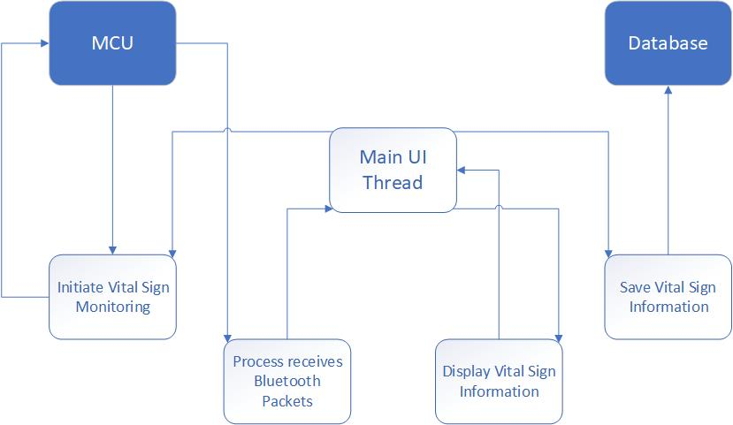
Figure 3. Block diagram showing the association between modules within the mobile application and the larger MNCVSM design. The white blocks are software modules within the application, and the blue blocks are a part of the larger MNCVSM system but are external to the mobile application.

    - User Interface
The Welcome screen is displayed when the application is first downloaded onto a device and every time the application is opened. The sequence of screens following an initial download will consist of the Welcome screen, Terms of Use screen, Bluetooth Setup screen, Personal Account Creation screen, and Tutorial screen. The actual content for these screens is still to be determined. After the initial setup, the Home screen will follow the Welcome screen whenever the application is opened.
The target features of this application are: continuous real-time graphs of the user’s heart and respiration rates, the ability to view the history of these vital signs, and the ability to send heart and/or respiration data via email. There will also be a Help screen, Settings screen, and Account Management screen. Figure 4 shows the proposed Welcome, Home, and History screens. Since the majority of users will not be medically-trained professionals, the pages will be clear of medical terminology.
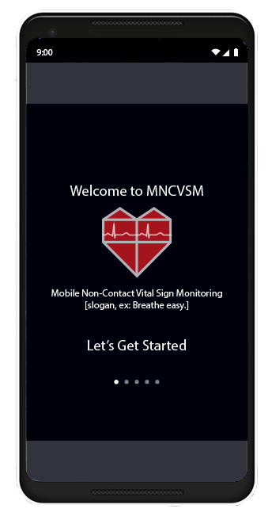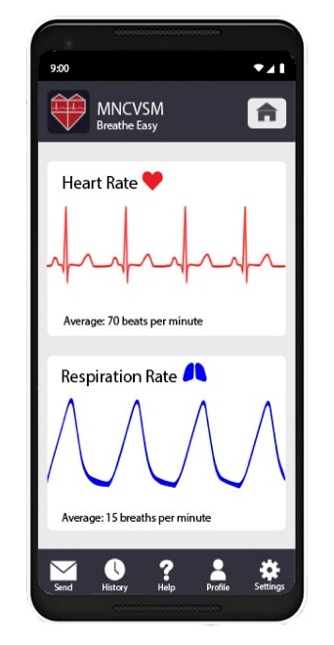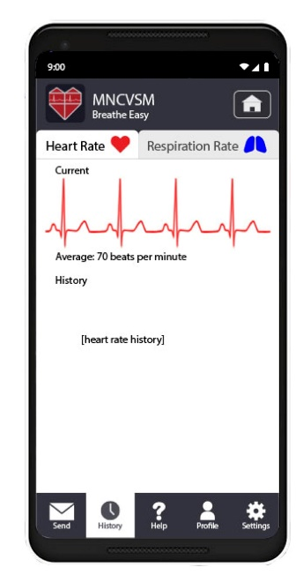
Figure 4. Proposed user interface for the MNCVSM application, from left to right: Welcome screen showing the product name and logo, Home screen showing the continuous real-time graph of the user’s heart rate and respiration rate, and History screen with tabs for heart and respiration rate history.

  - Codes and Standards
- The Health Insurance Portability and Accountability Act (HIPAA) is a law that enforces national standards for the security of electronic health-care related data. It features:
  - Restrictions on an individual’s health data, allowing only the patient and medical professionals assisting the individual to see it
  - Regulations for the online storage of medical information [13]
To ensure compliance with this law, The MNCVSM Team has will maintain appropriate levels of protection when storing vital sign information on the user’s mobile device. This has led to the decisions to use the Bluetooth communication protocol, to timeout inactive application sessions, and to encrypt any data saved in the mobile device’s storage.
- ANSI/AAMI ES60601-1:2005 is a standard that governs the accuracy of medical instruments. It features a specification that the SNR must be high enough to not mislead users [14]. When designing an algorithm to interpret the signals received by the system, there will need to be sufficient noise cancellation during the filtering process to ensure a low enough error rate to meet this standard.
- The Institutional Review Board for Protection in Human Subjects in Research is a body that provides ethical and regulatory oversight of research involving human subjects. It features protection of research participants’ rights, welfare, and well-being [15]. Dr. Zhang and her graduate students have received IRB approval and training with a signal power level of 6 dBm. Outputs obtained by IRB-trained students will be used when testing the design. Additionally, demonstrations of the entire system will only be done with the oversight of IRB-trained students.
- IEEE 802.15.1-2002 specifies wireless personal area network standards based on Bluetooth technology. It features:
  - Standard adaptations of the Bluetooth specifications
  - Specification of the physical layer and the Media Access Control for wireless connectivity [16]
Since the Bluetooth communication protocol provides fast, reliable, and secure communication, it allows for real-time transmission of vital sign information while providing HIPAA compliance. To make use of this protocol, a Bluetooth module needs to be connected to the system’s MCU, and the mobile device running the companion application must support Bluetooth communication.
- Android Open Source Project (AOSP) Java Code Style is a coding standard used for Java code contributions to official Android open source projects. It features:
  - Java language rules that define coding conventions
  - Java library rules that detail how changes may be made to existing libraries and prohibits the use of deprecated libraries
  - Java style rules that define stylistic guidelines to follow when writing code
  - Javatests style rules that define naming conventions to be used when creating test methods [17]
To ensure code readability and design reusability, the MNCVSM Team has decided to enforce a consistent coding style by following the guidelines outlined under this coding convention. This affects the way the mobile application’s pages and data structures will be designed.

    - Constraints, Alternatives, and Tradeoffs
    - Constraints
- The ability to extract vital sign data from the Doppler-based vital sign monitoring system is constrained by the noise content of the signal. If the amplitude of the noise present in the signal is greater than or equal to the amplitude of the vital sign data to be extracted, the vital sign measurements cannot be accurately obtained from the signal.
- To sustain the amount of data that must be processed on the MCU, the on-board ADC must have a minimum of 16-bit resolution, according to Dr. Zhang, the MNCVSM Team’s advisor. If the ADC does not have sufficient resolution, it cannot accurately collect the vital signal information to be communicated to the mobile application in real-time.
    - Alternatives
- Instead of using the Bluetooth wireless communication protocol, the Zigbee protocol can be used. Zigbee offers wireless communication with a longer range, lower latency, and lower power consumption than Bluetooth; however, it has security flaws and a maximum communication bandwidth around 3% of the bandwidth provided by Bluetooth [18]. To ensure that the system remains compliant with HIPAA, the information sent by the MCU will need to provide encryption to compensate for the security flaws. Additionally, the MCU must ensure that the data rate does not exceed the lower communication bandwidth, which may require further data processing on the MCU to select what should be sent to the mobile device.
- Instead of developing a mobile application for Android devices, an application for Apple devices can be created. An Apple application, unlike an Android application, would need to be written using the Swift programming language and would need to be reviewed and approved by Apple before appearing in the App Store. The Apple application development environment allows for security and Bluetooth communication guarantees similar to those in the Android application development environment. In April 2018, around 54% of all active mobile devices used the Google Android operating system, while around 44% used Apple iOS [19]. The median income of iPhone users is roughly 40% greater than the median income of Android users [20]. Although an Apple application may be accessible to a similar number of users to an Android application, an Apple application would only be accessible to more economically advantaged users.
    - Trade-offs
- To allow users to view their vital sign history, the mobile application must save the vital sign information either locally or in cloud storage. Utilizing the device’s local storage will allow immediate access to the vital sign history. However, the application would be limited by the device’s storage capacity and would need to determine which data should be deleted if no more data space can be allocated. A cloud storage system allows a seemingly limitless storage capacity and can be accessed from multiple devices but accessing vital sign history in cloud storage requires an internet connection and is limited by the bandwidth of that connection. Additionally, cloud storage services may require a service fee once the saved data exceeds a certain amount.
- The signals from the non-contact system received by the MCU must be processed to determine the user’s vital signs. This processing can be performed entirely on-board the MCU, entirely within the mobile application, or partially in each. Processing the data entirely on the MCU allows for only relevant vital sign data to need to be transferred to the mobile device. This processing would depend heavily upon the capabilities of the MCU and whether or not its ADC can handle the data throughput of the system. Processing the data entirely within the mobile application allows for more a more detailed analysis of the signal data and can take advantage of the processing power of the mobile device. However, if the rate at which raw data is being transferred to the mobile device exceeds the bandwidth capabilities of the Bluetooth connection, then data could be lost.
- Schedule, Tasks, and Milestones
Appendix A lists the tasks for this project, the anticipated risk level of each task, and the group member(s) responsible for each task. The tasks and milestones are shown in a time-linear format in the Gantt Chart shown in Appendix B. A PERT Chart, which identifies the critical path(s) for this project is included in Appendix C.
- Project Demonstration
  - Prototype Testing
The individual aspects of the design will be tested separately first to ensure that specifications are satisfied. After the verification of each aspect, the entire system will be integrated into a single product and tested as a whole. When the entire unit works correctly, it will be considered ready for final demonstrations. Here are the steps that will be taken for testing the prototype:
- A function generator will be used to simulate a real signal. It will be connected to the MCU to ensure accurate signal acquisition and processing.
- Pre-recorded vital sign data will be processed by the MCU to ensure accurate vital sign extraction.
- The Bluetooth communication channel will be tested to ensure accurate communication between the MCU and the mobile device.
- The functionality of the mobile application will be tested both using emulators within Android Studio and with physical Android devices to ensure proper operation.
- Pre-recorded vital sign signals will be used to test the accuracy of the overall system.
- A volunteer’s vital signs will be used to test the accuracy of the overall system in real-time.
  - Final Demonstration
The demonstration of the design will involve setting up the non-contact vital sign monitoring system and selecting volunteer users for monitoring. Each user will be asked to sit down in a chair and will be given an Android mobile device that is running the MNCVSM mobile application. The demonstration will proceed as follows:
- The user will navigate through the mobile application to initialize vital sign detection.
- The vital sign monitoring will begin, and statistics and graphs of the user’s vital signs will be displayed in the user interface of the mobile application in real-time.
- The user can then navigate through the mobile application to observe vital sign history and other features.

- Marketing and Cost Analysis
  - Marketing Analysis
The demographic for this design consists of emergency rescue teams, hospitals (particularly burn victim units and neonatal intensive care units), doctor’s offices, assisted-living and retirement homes, pharmacies, and individuals who suffer from chronic illnesses or want to monitor their vital signs on their own. Currently, there are no Doppler-based non-contact vital monitoring systems commercially available, though such devices exist. SENSIOTEC developed an Impulse Radio Ultra-Wideband sensor using Doppler-based non-contact vital sign monitoring technology. However, this sensor is currently not widely available due to its cost and use of specialized hardware [3], [11].
Despite the lack of commercially available Doppler-based non-contact vital sign monitoring technologies, there are other commercially available non-contact vital sign monitoring technologies, including the under-the-bed non-contact sensor developed by muRata [7]. The under-the-bed sensor PCB module with WiFi, which includes data transmission comparable to the MNCVSM Team’s design, is about $198.88 per unit [9]. The main advantage the MNCVSM Team’s design will have over the available technology is that the developed system will be portable, liberating users from being confined to a particular location, such as a bed. Further, it will provide users immediate access to vital sign information on a mobile application.
  - Cost Analysis
The parts needed to build the prototype include an MCU, an MCU evaluation board, a Bluetooth module, a Bluetooth module evaluation board, and 12 SMA connectors. Table 5 shows a breakdown of the material costs of the prototype. The total cost of the parts for a prototype of the MNCVSM device is approximately $388.63.

Table 5. Equipment Costs for Prototype
Product Description | Quantity | Unit Price | Cost
STM32F373VCT6 Microcontroller [21] | 1 | $5.81 | $5.81
STM32F373VCT6 Evaluation Board [22] | 1 | $248.75 | $248.75
SPBT3.0DP1 Bluetooth Classic Module [23] | 1 | $14.10 | $14.10
SPBT3.0DP1 Bluetooth Classic Module Evaluation Board [24] | 1 | $47.25 | $47.25
CON-SMA-EDGE-S Jack Connector [25] | 4 | $1.74 | $6.96
CCSMA-MM-086-8 Coaxial Cable [26] | 4 | $10.68 | $42.72
132169 Coaxial Connector [27] | 4 | $5.76 | $23.04
Total |  |  | $388.63

The annual salary for a typical Electrical/Computer Engineer with a 40-hour work week is about $70,000. An engineer who receives two weeks of holidays and two weeks of paid time-off per year works 48 weeks each year; this translates to an hourly labor cost of $36.46 [28]. Table 6 shows the estimated labor time and cost per engineer on the MNCVSM Team. Each engineer is estimated to work a total of 175 hours for an individual labor cost of $6,380.21. This includes weekly meetings, research and design, assembly and testing, and writing reports. Based on these estimates, the total labor time and cost for five engineers are estimated to be 875 hours and $31,901.04, respectively.
Table 6. Labor Costs per Engineer on the MNCVSM Team
 | Total Hours | Cost
Weekly Meetings | 14 | $510.42
Research | 28 | $1,020.83
Design | 28 | $1,020.83
Assembly and Testing | 77 | $2,807.29
Reports | 28 | $1,020.83
Total | 175 | $6,380.21
Assuming 30% fringe benefits of labor and 120% overhead on materials/labor/fringe benefits, the total development cost of the prototype of the MNCVSM device and mobile application is $92,091.95, as shown in Table 7.
Table 7. Total Development Costs
Development Component | Cost
Parts | $388.63
Labor | $31,901.04
Fringe Benefits, 30% of Labor | $9,570.31
Subtotal | $41,859.98
Overhead, 120% of Material, Labor, & Fringe Benefits | $50,231.97
Total | $92,091.95

The MNCVSM Team approximates that 5,000 units will be produced and sold at a unit price of $300 over a period of five years. To implement a production-ready design and to eliminate the costs associated with the evaluation board for the MCU, the Bluetooth module, and the SMA connectors, a custom PCB will be designed to replace those parts and provide the same functionality. The MNCVSM Team estimates that the custom PCB will cost $20 per unit. Table 8 details the costs associated with the custom PCB and the other parts that need to be purchased for producing 5,000 units.
Table 8. Equipment Costs for Producing 5,000 Units
Product Description | Quantity | Unit Price | Cost
STM32F373VCT6 Microcontroller [21] | 5,000 | $3.51 | $17,550.00
SPBT3.0DP1 Bluetooth Classic Module [23] | 5,000 | $14.10 | $70,500.00
Custom PCB Design | 5,000 | $20.00 | $100,000.00
Total |  |  | $188,050.00
Cost Per Unit |  |  | $37.61
The sales expense, for marketing and advertising, will be 7% of the final sale price, which translates to an expense of $21. The expected revenue for producing and selling 5,000 units at a price of $300 is $1,500,000, which will yield a profit of $92.46 per unit and a total profit of $462,290 over the five-year period. The percent of revenue that is profit for each unit sold is 30.82%. The production costs, profit, and selling price of the final product are displayed in Table 9.
Table 9. Selling Price and Profit per Unit
Description | Cost
Parts | $37.61
Fabrication Labor | $10.00
Assembly Labor | $10.00
Testing Labor | $10.00
Total Labor | $30.00
Fringe Benefits, 30% of Labor | $9.00
Subtotal | $76.61
Overhead, 120% of Material, Labor, & Fringe Benefits | $91.93
Subtotal, Input Costs | $168.54
Sales Expense | $21.00
Amortized Development Costs | $18.00
Subtotal, All Costs | $207.54
Profit | $92.46
Selling Price | $300.00

- Current Status
The STM32F373VCT6 MCU and the STMicroelectronics SPBT3.0DP1 Bluetooth Classic module will be used for building the prototype of this design. The prototype will be developed for Android version 5.0, and the MNCVSM Team has begun to draft screen layouts for the user interface that will be used when developing the mobile application in Android studio. Preliminary research of signal processing techniques and communication methods to be used when developing the prototype has been completed, but research of mobile device options and their processing capabilities has yet to be finished.

- References
[1] Z. Xia, M. Shandhi, O. Inan, and Y. Zhang, “Non-Contact Sensing of Seismocardiogram Signals Using Microwave Doppler Radar,” IEEE Sensors Journal, vol. 18, no. 14, pp. 5956-5964, July, 2018.
[2] Z. Lasater, J. Rosker, A. Elsabbagh, A. Genutis, and A. Renuart, “Non-Contact Analysis of Health-Informatics via Observable Metrics,” May 3, 2018.
[3] T. Hall, D. Lie, T. Nguyen, J. Mayeda, P. Lie, J. Lopez, and R. Banister, “Non-Contact Sensor for Long-Term Continuous Vital Signs Monitoring: A Review on Intelligent Phased-Array Doppler Sensor Design,” Sensors, vol. 17, no. 11, pp. 2632-2651, Nov. 2017.
[4] DPP Mag, “Monochrome Digital Cameras,” Gear, May 4, 2015. [Online]. Available: https://www.digitalphotopro.com/gear/professional-cameras/monochrome-capture/. [Accessed: Nov. 28, 2018].
[5] J. Lagasse, “Continuous monitoring tools could save hospitals $20,000 per bed, report says,” Healthcare IT News, Aug. 4, 2016. [Online]. Available: https://www.healthcareitnews.com/
news/continuous-monitoring-tools-could-save-hospitals-20000-bed-report-says. [Accessed: Nov. 28, 2018].
[6] muRata, SCA10H datasheet, Sep. 2015 [Revised Aug. 2016].
[7] muRata, SCA11H datasheet, Sep. 2015 [Revised Dec. 2015].
[8] “SCA10H-D01-112 Murata Electronics North America,” Digi-Key. [Online]. Available: https://www.digikey.com/product-detail/en/murata-electronics-north-america/SCA10H-D01-112/490-16645-ND/7595506. [Accessed: Nov. 28, 2018].
[9] “SCA11H-A01-036 Murata Electronics North America,” Digi-Key. [Online]. Available: https://www.digikey.com/product-detail/en/murata-electronics-north-america/SCA11H-A01-036/490-14344-ND/6605973. [Accessed: Nov. 28, 2018].
[10] C. Li, J. Ling, J. Li, and J. Lin, “Accurate Doppler Radar Noncontact Vital Sign Detection Using the RELAX Algorithm,” IEEE Transactions on Instrumentation and Measurement, vol. 59, no. 3, pp. 687–695, Mar. 2010.
[11] F. Zhao, M. Li, Z. Jiang, J. Z. Tsien, and Z. Lu, “Camera-Based, Non-Contact, Vital-Signs Monitoring Technology May Provide a Way for the Early Prevention of SIDS in Infants,” Frontiers in Neurology, vol. 7, Dec. 2016.
[12] STMicroelectronics, STM32F373xx datasheet, Jun. 2012 [Revised Jun. 2016].
[13] Office for Civil Rights, “HIPAA for Professionals,” HHS.gov, June 16, 2017. [Online]. Available: https://www.hhs.gov/hipaa/for-professionals/index.html. [Accessed: Nov. 28, 2018].
[14] Medical electrical equipment - Part 1: General requirements for basic safety and essential performance, ANSI/AAMI ES60601-1:2005, Jan. 17, 2012.
[15] “Institutional Review Board,” National Institute of Environmental Health Sciences, Oct. 29, 2018. [Online]. Available: https://www.niehs.nih.gov/about/boards/irb/index.cfm. [Accessed: Nov. 28, 2018].
[16] IEEE Standard for Telecommunications and Information Exchange Between Systems - LAN/MAN - Specific Requirements - Part 15: Wireless Medium Access Control (MAC) and Physical Layer (PHY) Specifications for Wireless Personal Area Networks (WPANs), IEEE 802.15.1-2002, May 14, 2002.
[17] “AOSP Java Code Style for Contributors,” android.com. [Online]. Available: https://source.android.com/setup/contribute/code-style. [Accessed: Nov. 28, 2018].
[18] M. Christiano, “ZigBee vs Bluetooth and Bluetooth Smart,” ALL ABOUT CIRCUITS, Sep. 9, 2015. [Online]. Available: https://www.allaboutcircuits.com/technical-articles/zigbee-vs
-bluetooth-and-bluetooth-smart/. [Accessed: Nov. 28, 2018].
[19] “Subscriber share held by smartphone operating systems in the United States from 2012 to 2018,” statista. [Online]. Available: https://www.statista.com/statistics/266572/market-share
-held-by-smartphone-platforms-in-the-united-states/. [Accessed: Nov. 28, 2018].
[20] A. Lella, “iPhone Users Earn Higher Income, Engage More on Apps than Android Users,” comscore, Aug. 14, 2014. [Online]. Available: https://www.comscore.com/Insights/
Infographics/iPhone-Users-Earn-Higher-Income-Engage-More-on-Apps-than-Android-Users. [Accessed: Nov. 28, 2018].
[21] “STM32F373VCT6 STMicroelectronics,” Digi-Key. [Online]. Available: https://www.digikey.com/products/en/integrated-circuits-ics/embedded-microcontrollers/685?k=STM32F373VCT6%20Microcontroller. [Accessed: Nov. 28, 2018].
[22] “STM32373C-EVAL STMicroelectronics,” Digi-Key. [Online]. Available: https://www.digikey.com/products/en?keywords=STM32F373VCT6%20Evaluation%20Board. [Accessed: Nov. 28, 2018].
[23] “STEVAL-BTDP1 STMicroelectronics,” Digi-Key. [Online]. Available: https://www.digikey.com/products/en?keywords=SPBT3.0DP1%20Bluetooth%20Classic%20Module. [Accessed: Nov. 28, 2018].
[24] “STEVAL-BTDP1 STMicroelectronics,” Digi-Key. [Online]. Available: https://www.digikey.com/products/en?keywords=SPBT3.0DP1%20Bluetooth%20Classic%20Module%20Evaluation%20Board. [Accessed: Nov. 28, 2018].
[25] “CON-SMA-EDGE-S RF Solutions,” Digi-Key. [Online]. Available: https://www.digikey.com/
products/en?keywords=CON-SMA-EDGE-S%20Jack%20Connector. [Accessed: Nov. 28, 2018].
[26] “CCSMA-MM-086-8 Crystek Corporation,” Digi-Key. [Online]. Available: https://www.digikey.com/products/en?keywords=CCSMA-MM-086-8%20Coaxial%20Cable. [Accessed: Nov. 28, 2018].
[27] “Amphenol RF Division 132169,” Digi-Key. [Online]. Available: https://www.digikey.com/
product-detail/en/amphenol-rf-division/132169/ACX1242-ND/1011919. [Accessed: Nov. 28, 2018].
[28] S. Adams. “The College Degrees With The Highest Starting Salaries,” Forbes, Sep. 20, 2013. [Online]. Available: https://www.forbes.com/sites/susanadams/2013/09/20/the-college
-degrees-with-the-highest-starting-salaries/#37b0382b5c0d. [Accessed: Nov. 28, 2018].

Appendix A - Task Leads and Risk Levels
NJ - Nydrel Jack, AP - Arianne Perez, CT - Chelsi Taylor, EV - Ethan Vargas, NW - Nathanael Williams
TASK | Task Lead | Risk Level
Phase I (Fall 2018) -- Planning
Research
Codes and standards for project | All | Low
MCU options, processing capability of MCUs | CT | Low
Signal processing methods for vital sign signals | NW | Low
Communication between MCU and mobile device | EV | Low
Bluetooth capability of MCUs | EV | Low
Mobile device options for mobile application, focus on  processing capability | NJ, EV | Low
Deliverables
Project Summary Form (Draft) | All | Low
Project Summary Form (Final) | All | Low
Project Proposal | All | Low
Individual Design Notebooks (Phase I) | All | Low
Phase II (Spring 2019) -- Implementation
Preliminary Tasks
Proposal Presentation | All | Low
Acquire pre-recorded vital sign signals for testing | All | Low
Determine data processed on MCU versus on mobile device | NJ, CT, EV | High
Order Parts | CT | Low
MCU Data Acquisition and Signal Processing
Design on-board algorithm to process data | CT, NW | Medium
Test on-board algorithm using a function generator, verify  accuracy | CT, NW | Medium
Test on-board algorithm using pre-recorded vital sign signals,  verify accuracy | CT, NW | Low
Wireless Communication | CT
Connect and establish a Bluetooth module between the MCU  and mobile device | CT | Medium
Test wireless communication channel, verify accuracy | CT | Low
Communicate processed or raw data from the MCU to mobile  device | NJ | Medium
Mobile App
Determine Android version to use for mobile application | NJ, EV | Low
Design user interface for mobile device | AP | Low
Implement user interface design | AP | Low
Design algorithm to process data sent from the MCU | EV | High
Design database for storing vital sign information | NJ | Low
Develop module to plot processed data | AP | Low
Develop module to initiate vital sign monitoring | NJ | High
Develop module to save processed data points | EV | Medium
Compile and export companion mobile application | NJ | Medium
Testing (Entire System -- MCU + Wireless Communication + Mobile App)
Use pre-recorded vital sign signals, show on mobile device | All | Low
Use real-time vital sign signals of volunteer subjects, show on mobile device | All | Medium
Phase III (May 2019) -- Compilation and Presentations
Compile important results, figures, information, etc. | All | Low
Individual Design Notebooks (Phase II and Phase III) | All | Low
Design Expo Poster | AP, CT | Low
Project Website | NW | Low
Final Presentation / Design Expo Presentation | All | Medium
Final Report | All | Low

Appendix B - Comprehensive Gantt Chart
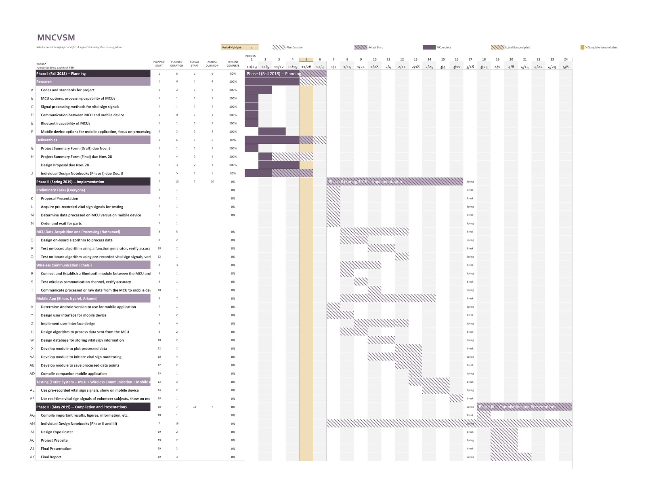
Appendix C - Project PERT Chart with Critical Paths Identified
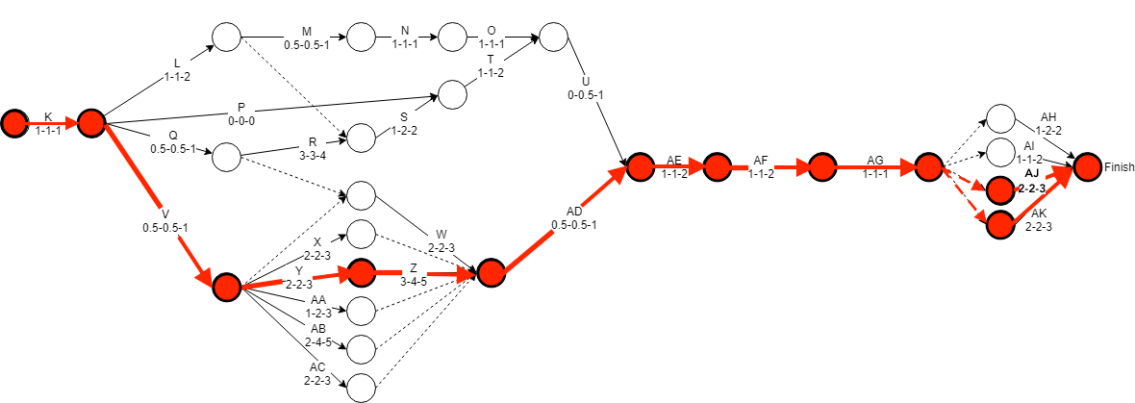
The lettering for the tasks in PERT chart corresponds to the lettering of the tasks in Appendix B.

